**Comprehensive Prediction of Depressed Patients using Machine Learning Techniques and it’s Outcome Assessment**

**ABSTRACT**

The use of wearable sensor technologies has grown in popularity as a means of tracking many facets of human activity.In this paper, a unique dataset consisting of motor activity recordings from patients with depression have been analysed .These activity data help to detect various mental health issues such as changes in mood, personality, inability to cope with daily problems or stress and withdrawal from friends and activities. Here machine learning methods have been deployed to classify people into sad and non-depressed groups.The dataset consists of actigraph data as well as clinical scores, such as MADRS(Montgomery–Åsberg Depression Rating Scale) and detailing about the patients' psychiatric conditions.The dataset contains motor activity recordings of 23 unipolar and bipolar depressed patients and 32 healthy controls. Machine learning models specifically Random Forest Classifier & Decision Tree Classifierhave been applied for multiple classification tasks, including prediction of the level of depression of patient before treatment, prediction of the level of depression of patient after treatment,classification of the type of depression of patient’s (e.g., bipolar II, unipolar depressive), determination of the patient's status (inpatient or outpatient), assessment of the improvement in depression after treatment , classification of marital status of patients, identification of melancholic conditions of patients and also classification of patients on the basis of their works(e.g. working or studying,unemployed/sick leave/pension) have be addressed .Furthermore we augment the dataset size using Genetic algorithms, employing CrossOver technique to expand the dataset. All eight machine learning prediction models are applied to this synthetic dataset to assess the generalizability of all models.Model performance and reliability across varying data volumes can be understood through comparative studies between the original and expanded datasets.Additional analyses also measured the influence of model predictions on a range of characteristics, including gender, afftype, work status, marital status, melancholic/non-melancholic status, and patient status. Analyses that are specific to the model showed how patients are distributed across various depression levels, types of depression, improvement in condition, and classification according to expected characteristics. Through the use of machine learning techniques, these analyses advance our understanding of depression classification and attribute prediction.

**Keywords:** Genetic Algorithm,CrossOver,Random Forest Classifier & Decision Tree Classifier

**CHAPTER 1**

**INTRODUCTION**

* 1. **Introduction**

The way we monitor and comprehend human behaviour has changed dramatically with the introduction of wearable sensor technologies into everyday life. Apart from the typical step and calorie tracking, continuous heart rate and activity level recordings are a valuable source of information. Acknowledging the possible consequences for mental health evaluation, this report explores the examination of a distinct dataset gathered from persons battling depression. The collection includes motor activity recordings from 32 healthy controls and 23 patients with unipolar and bipolar depression.New methods are being investigated as psychiatry becomes more aware of the connection between activity data and mental health. Based on sensor data, this study uses machine learning to classify people into depressed and non-depressed states using classification models like Random Forest and Decision Tree. The goal is to provide new light on the complex interactions that exist between wearable sensor data and mental health issues.

A serious mental illness called depression can cause a wide range of symptoms, such as melancholy, worry, trouble sleeping, and loss of interest in activities. The situation is made more difficult by the hereditary foundations of both bipolar and unipolar diseases. Bipolar illness differs from unipolar depression in that it is characterised by recurrent manic episodes, which makes diagnosis and treatment more difficult.

The intricacy of sadness is exacerbated by disrupted biological cycles, which are linked to social, physical, and environmental variables.According to **WHO** One prevalent mental illness is depression. It is estimated that 5% of adults worldwide are affected by the disorder. Persistent melancholy and a lack of interest in or enjoyment from once-fulfilling or enjoyable activities are its defining characteristics. Sleep and appetite can also be affected by it. Fatigue and lack of focus are prevalent. Globally, depression is one of the main causes of disability and a major contributor to the overall burden of disease. A person's capacity to function and lead a fulfilling life can be significantly impacted by the long-lasting or recurrent effects of depression.Depression is brought on by a complex interplay of biological, psychological, and social factors. Adversity in childhood, grief, and unemployment are examples of life events that can both contribute to and trigger the onset of depression. There are **medications and psychological** therapies available for depression. However, depression treatment and support services are frequently lacking or inadequate in low- and middle-income nations. It is estimated that in these countries, over 75% of individuals with mental illnesses do not receive treatment.

The importance of depression is highlighted by the fact that it affects 15% of people worldwide. Actigraph recordings of motor activity have become a valuable tool for objectively observing depression, providing a means of ongoing observation and evaluation. Still, not much has been studied in this area of psychiatric study.

In this regard, our research aims to utilise wearable sensor data to predict the kind, severity, and concomitant conditions of depression in addition to classifying it. An additional degree of complexity to the analysis is added by using Random Forest and Decision Tree models, which are well-known for their robustness and interpretability. To thoroughly evaluate model performance, the methodology uses leave-one-patient-out validation.

This project methodology, outcomes, machine learning models used, and dataset structure are all covered in detail in the sections that follow. We hope that this investigation will provide insightful information about the expanding field of wearable technology and mental health, potentially leading to improvements in our knowledge of and ability to treat depression.

**1.1.1 Types Of Depression**

The types of depression include:

**1.Major Depressive Disorder,** commonly referred to as clinical depression or unipolar, experience a persistently melancholic mood. It may interfere with day-to-day activities and make them disinterested in things they would normally find enjoyable. It is a mood disorder characterized bseveral features like Depressed mood,lack of interest in activities in any activities normally enjoyed,changes in weight,fatigue,feelings of guilt and worthlessness,lose concentration power,Thoughts of death and suicide.

If a person experiences the majority of these symptoms for longer than a two-week period, they will often be diagnosed with MDD.

**2.Persistent Depressive Disorder**

Persistent depressive disorder, formerly known as dysthymia, is a kind of chronic depression that has been present on more days than not for at least two years. It may be moderate, severe, or mild.Although people may have brief periods of time when they don't feel depressed, these periods of relief typically only last two months or less. The symptoms are widespread and persistent, despite not being as bad as those of major depressive disorder.

Psychotherapy and medicine are often used in the treatment of persistent depressive disorder.

**3.Bipolar Disorder**

Manic episodes, also known as periods of unusually elevated mood, are the hallmark of bipolar disorder. These episodes can range from mild (hypomania) to severe enough to seriously impair a person's life, necessitate hospitalisation, or impair their perception of reality. Major depressive episodes occur in almost all bipolar disorder patients.People with depression frequently experience a variety of physical and emotional symptoms, in addition to their depressed mood and noticeably decreased interest in activities. These symptoms may include:Lethargy, sleeplessness, and fatigue,Unknown aches, pains, and agitation in the psychomotor domain ,Desperation and diminished self-worth,,Intolerance and uneasiness,Lack of focus.

**4.Postpartum Depression**

Significant hormonal changes that can occur during pregnancy can frequently have an impact on a woman's mood. Depression can start during or after a pregnancy and the birth of a child.Postpartum depression (PPD), currently categorised as depression with peripartum onset, is more than just the "baby blues."After giving birth, mood swings, anxiety, irritability, and other symptoms are common and can persist for up to two weeks. The symptoms of PPD are more severe and persistent.

**5.Seasonal Affective Disorder**

If you feel fine in the spring but suffer from depression, insomnia, and weight gain in the winter, you might have seasonal affective disorder (SAD).

Currently known as seasonal pattern major depressive disorder.

It is thought that a disruption in the body's typical circadian rhythm causes SAD.This rhythm is influenced by light entering the eyes, and any seasonal change in the pattern of day and night can throw it off, potentially resulting in depression.

**6.Atypical Depression**

Surprisingly, atypical depression is more common than its name suggests. Individuals with atypical depression may react more favourably to antidepressants known as monoamine oxidase inhibitors (MAOIs) than to other types of depression.Overeating or gaining weight

Oversleeping Fatigue, debility, and a sense of being "weighed down" high susceptibility to rejection,intensely reactive emotions.

**7.Melancholic** characteristics include extreme depression accompanied by a lack of reaction to previously pleasurable experiences, early morning awakenings, a worsened mood in the morning, significant changes in appetite, and emotions of guilt, agitation, or lethargy.

**1.1.2 Causes Of Depression**

Depression can arise from a multitude of factors, such as genetic, environmental, psychological, and biochemical ones.A person is more likely to experience depression if they have trauma, significant life changes, stress, a family history of depression, certain physical illnesses (like diabetes, cancer, or Parkinson's disease), or as a side effect of certain medications.

**1.2 Montgomery–ÅsbergDepression Rating Scale (MADRS)**

Over the past few decades, MADRS has been widely used to measure depression because it is the most commonly used and effective measure in antidepressant efficiency trials. This scale's primary objective is to evaluate depressive symptomology, especially as it relates to antidepressant-treated patients. A clinical interview serves as the basis for the MADRS rating system. In order to find the patient's severity on the rating scale, the interviewer typically advances from a generalised, generalised question about the symptoms the patient is experiencing to a more specific, detailed question. When interviewing and grading a patient in the MADRS, the interviewer takes the following factors into account:

* Apparent Sadness
* Reported Sadness
* Inner Tension
* Reduced Sleep
* Reduced Appetite
* Concentration Difficulty
* Lassitude
* Inability to Feel
* Pessimistic Thoughts
* Suicidal Thoughts

This 10-item clinician-rated measure has a maximum total score of 60 points; higher scores are indicative of greater depressive symptomology. Each item is rated on a 0–6 scale.According to the MADRS scoring guidelines, a total score of 0 to 6 means the patient is not depressed; a score of 7 to 19 means mild depression; a score of 20 to 34 means moderate depression; a score of 35 and higher means severe depression; and a total score of 60 or higher means very severe depression. There is proof that a two-point increase on the MADRS or higher is regarded as clinically significant.

**1.3 MOTIVATION FOR THE WORK**

The work is motivated by a deep understanding of the substantial effects that depression has on people and society as a whole. Depression is a widespread and intricate mental health issue that impacts millions of individuals worldwide. The traditional approaches to diagnosis and tracking frequently depend on sporadic evaluations, which leaves out the complex subtleties of everyday experiences . When combined with cutting-edge machine learning models, wearable sensor technologies offer a once-in-a-lifetime chance to revolutionise mental health assessment. The drive comes from the possibility of filling in the gaps in conventional diagnostic methods by providing a continuous and instantaneous understanding of people's mental health. The goal of this work is to offer a more comprehensive and individualised view of depression by going beyond episodic assessments and towards ongoing, data-driven insights.

Several key motivations propel this exploration:

1.**Holistic Mental Health Assessment:**Conventional methods often provide episodic snapshots of mental health. The motivation is to move beyond these sporadic assessments and embrace continuous, real-time monitoring through wearable sensors. This approach promises a more holistic understanding of individuals' mental well-being.

2.**Unveiling Nuances in Depression Patterns:** A unique opportunity to record minute patterns and variations in daily activities that might be associated with mood and mental health changes is provided by wearable sensors. The goal is to decipher these subtle cues in order to possibly offer early warning signs of depression and its different forms.

3.**Contribution to Digital Mental Health:**A greater dedication to developing the field of digital mental health serves as the driving force behind this work. Through investigating the potential benefits of wearable technology and machine learning, the project hopes to add to the increasing amount of research on cutting-edge technological approaches for enhancing mental health outcomes.

4.**Revolutionizing Diagnostic Precision:**The accuracy required to accurately understand depression is frequently lacking in current diagnostic methods. The goal is to use machine learning models that can process large amounts of data from wearable sensors to revolutionise diagnostic accuracy and provide a more accurate and nuanced picture of a patient's mental health.

**5.Addressing the Complexity of Depression:**Depression is a multifaceted disorder with various contributing factors. Wearable sensors and machine learning present an opportunity to address this complexity.The motivation is rooted in the desire to unravel the intricate relationships between continuous activity data and mental health, potentially uncovering novel insights that contribute to a more holistic understanding of depression.

In conclusion, the Purposes of my works is motivated by a commitment to advancing mental health research and care through innovative technologies. The goal is to harness the power of wearable sensors and machine learning to provide nuanced, personalized insights into depression, ultimately improving diagnostic accuracy and patient outcomes.

**1.4 PROBLEM STATEMENT**

My project/problem statement was **"Comprehensive Prediction of Depressed Patients using Machine Learning Techniques and it’s Outcome Assessment".**

**1.4.1 Data Collection**

The dataset was originally collected for the study of motor activity in schizophrenia and major depression https://bmcresnotes.biomedcentral.com/articles/10.1186/1756-0500-3-149. Motor activity was monitored with an actigraph watch worn at the right wrist (Actiwatch, Cambridge Neurotechnology Ltd, England, model AW4). The actigraph watch measures activity levels. The sampling frequency is 32Hz and movements over 0.05 g are recorded. A corresponding voltage is produced and is stored as an activity count in the memory unit of the actigraph watch. The number of counts is proportional to the intensity of the movement. Total activity counts were continuously recorded in one minute intervals.

**1.4.2 Dataset Details**

The following information is included in the dataset: Two folders, one holding the condition group's data and the other the controls'. We provide a csv file with the actigraph data gathered over time for every patient. The timestamp (one-minute intervals), date (the measurement date), and activity (the actigraph watch's activity measurement) are the columns. Furthermore, the MADRS scores are available in the file \emph{scores.csv}. The patient identifier (number), the number of measurement days, the gender (1 or 2 for female or male), the age (age in age groups), the afftype (1: bipolar II, 2: unipolar depressive, 3: bipolar I), the melancholy (1: melancholia, 2: no melancholia), the inpatient (1: inpatient, 2: outpatient), the edu (education grouped in years), and the marriage (1: married or cohabiting, 2:single), work (1: working or studying, 2: unemployed/sick leave/pension), madrs1 (MADRS score when measurement started), madrs2 (MADRS when measurement stopped).

**1.4.3Acknowledgements**  
The vision of this dataset is that the available data eventually helped me to develop systems that is capable of automatically detecting depression states based on sensor data and MADRS score(score data).This dataset can be suitable (but not limited to) for performing tasks like : Machine learning models specifically Random Forest Classifier & Decision Tree Classifier are applied for multiple classification tasks, including predicting the level of depression before and after treatment , classifying the type of depression of patient’s (e.g., bipolar II, unipolar depressive), determining the patient's status (inpatient or outpatient), assessing the improvement in depression after treatment, classifying marital status of patients, identifying melancholic conditions of patients and also classifying patients on the basis of their works(e.g. working or studying,unemployed/sick leave/pension).This dataset can be used as the basis for evaluating different machine learning methods and approaches such as: cost-sensitive classification and oversampling techniques for imbalanced class problems.

**CHAPTER 2**

**LITERATURE SURVEY/REVIEWS**

A literature survey is a crucial component of any research project, providing a foundation for my work and placing it within the broader context of existing knowledge. Below is a concise literature survey for our project on wearable sensors, machine learning, and mental health:

[1] Wearable Sensors for Emotional Wellness:

Walsh, L., Giggins, O. M., Clay, I., and McDonnell, C. (2018). An RCT was conducted to evaluate the effects of wearable lower limb haptic feedback on gait rehabilitation in patients at high risk of falls.

Chan, L., Bonato, P., Park, H., Patel, S., & Rodgers, M. (2012). a summary of wearable technology and systems that are used in rehabilitation.

These studies demonstrate how wearable sensors can be used to track physical activity and highlight their potential applications in rehabilitation settings.

[2] AI in Mental Health:

V. Osmani (2015). Smartphones and mental health: identifying periods of mania and depression.Iniesta, R., McGuffin, P., and Stahl, D. (2016). The future of biological research in psychiatry, machine learning, and statistical learning.

These articles demonstrate the use of machine learning in mental health, including the use of cellphones to detect depressive episodes and the wider consequences for psychiatric biological research.

[3] Depression and Wearable Sensors:

Together with Schueller, S. M., Corden, M. E., Kording, K. P., Zhang, M., Karr, C. J., Saeb, S., & Mohr, D. C. (2015)? An exploratory study on the correlations between the severity of depressive symptoms in daily life and mobile phone sensors.

Musolesi, M., and L. Canzian (2015). Depression trajectories: discreet tracking of depressive states through analysis of smartphone movement traces.

These investigations focus on the precise correlation between wearable sensor data—especially from mobile phones—and the degree of depressive symptoms experienced on a daily basis.

[4] Automated Learning in Mental Health Research:

Davatzikos, C., and N. Koutsouleris (2014). Machine learning for the classification of psychiatric diseases.Meyer-Lindenberg, A., and D. Bzdok (2018). Prospects and difficulties for precision psychiatry using machine learning.

These studies examine the wider field of machine learning in psychiatric research, going over issues like precision psychiatry's opportunities and difficulties as well as the technology's potential for categorising mental illnesses.

[5] Integrative Methods for Tracking Mental Health: Onaral, B., & Xing, D. (2012). The patient's perspective on wearable and implantable sensors.

Zhang, M., Schueller, S. M., and D. C. Mohr (2017). Personal sensing is the use of machine learning and widely distributed sensors to understand mental health.

These papers address the application of personal sensing and machine learning for understanding mental health and offer insights into the patient's perspective on wearable and implantable sensors.

This literature survey provides a starting point for understanding the existing research landscape in wearable technology, machine learning, and depression classification.

According to basis of this literature survey i should continues my work and make machine learning classification model for depressive patients and also try to see current situation of patients that is patient situation after giving him a treatment . .

**CHAPTER 3**

**METHODOLOGY**

**3.1 EXISTING SYSTEM**

Machine Learning Models for Depression Classification: The field of applying machine learning to the classification of depression is one that is fast developing. Current systems use decision trees and random forests as algorithms to accurately classify data from a variety of sources.the problem with this models is that it did not give proper accuracy. So we could try to make machine learning model for depression classification such a that the model could perform better than existing model means the accuracy of models should be excellent.

In [1], Walsh and colleagues (2018) introduced a novel method for gait recovered utilizing wearable lower limb haptic feedback, based on a randomized controlled trial (RCT) involving 60 patients at high risk of falls.In [2], Osmani (2015) proposed a smartphone-based approach to detect periods of mania and depression, containing smartphone data.In [3], Schueller et al. (2015) conducted an exploratory investigation into the relationship between depressive symptoms and data from mobile phone sensors.In [4], Davatzikos and Koutsouleris (2014) explored the application of machine learning for the classification of psychiatric diseases.In [5], Onaral and Xing (2012) discussed the patient's perspective on wearable and implantable sensors, without referencing a particular study or sample size. In [6], Chan et al. (2012) provided an overview of wearable technology and systems used in rehabilitation, offering insights into their potential applications.In [7], Musolesi and Canzian (2015) investigated depression trajectories through the analysis of smartphone movement traces, contributing to the understanding of wearable sensor data in mental health research.In [8], Iniesta et al. (2016) explored the future of biological research in psychiatry, including the integration of machine learning techniques. However, no specific study or sample size was mentioned.In [9], Meyer-Lindenberg and Bzdok (2018) discussed the prospects and challenges of precision psychiatry using machine learning, emphasizing its potential impact on mental health research. Specific research studies or sample sizes were not provided.In [10], Zhang et al. (2017) examined personal sensing and machine learning for understanding mental health, highlighting the importance of integrating these technologies for personalized care.

**3.2 PROPOSED SYSTEM**

We have conducted a thorough process of data preparation and exploration in the first phase of my study on original dataset as well as enhanced size dataset , including data cleaning, preprocessing, and exploratory data analysis (EDA).We started my method by fixing the dataset's missing values.We imputed missing data points using statistical measures like mean, median, and mode in order to close these gaps. In addition, for consistency ,We used the ceil function to round off numerical attributes.After the data was cleaned, We turned our attention to making sure the different types of data were compatible with the analysis that followed.   
After finishing the first data cleaning procedure,Utilizing the pandas package,We conducted in-depth statistical analysis and visualization, gaining profound insights into dataset properties and structure. Unnecessary characteristics were eliminated to enhance model performance and reduce computational complexity. Additionally, continuous values were discretized into categorical ones through label encoding on particular attributes, such age and the number of measurement days, enabling effective incorporation into machine learning models.From pandas profiling we gained deeper understanding of the dataset's properties and structure.We used the RandomOverSampler technique for oversampling in order to address the class imbalance issues present in the dataset. This reduced biases in later analyses by ensuring a fair representation of classes. After oversampling, We divided the data into target and training sets, reserving the remaining portion for model testing and used between 60 to

80% of the data for model training.To make the data more uniform We used standardisation approaches, such as the StandardScaler and MinMaxScaler methods, to standardise the data and bring it to a uniform scale. The values were standardised by these changes, which prepared them for further analysis.After preprocessing and preparing the data,We created our models. By utilising diverse supervised learning algorithms, like Random Forest and Decision Tree, we were able to create unique sub-models that were customised to meet different parts of our study goals.We used accuracy, precision, recall, and F1 score as important measures for assessing model performance.Through this analysis We revealed information on how well each model captured underlying patterns in the data.All things considered, my methodology comprised a methodical approach that included model creation, performance evaluation, and data preprocessing. By using this exacting procedure,our goal was to produce reliable and accurate predictions in the domain of mental health assessment using wearable sensor data.Furthermore we augment the dataset size using Genetic algorithms, employing CrossOver technique to expand the dataset. All eight machine learning prediction models are applied to this synthetic dataset to assess the generalizability of all models.Model performance and reliability across varying data volumes can be understood through comparative studies between the original and expanded datasets.Additional analyses also measured the influence of model predictions on a range of characteristics, including gender, afftype, work status, marital status, melancholic/non-melancholic status, and patient status. Analyses that are specific to the model showed how patients are distributed across various depression levels, types of depression, improvement in condition, and classification according to expected characteristics. Through the use of machine learning techniques, these analyses advance our understanding of depression classification and attribute prediction.

sub models are as follows:

**MACHINE LEARNING MODEL NO 1: “Create Machines Learning model for Predicting the MADRS1 score of persons/patients and on the basis of that score signify the level of depression in person/patients.”**

**Independent attributes:**days,age,gender,afftype,melanch,inpatient,marriage and work.

**Dependent attributes:**MADRS1

**MACHINE LEARNING MODEL NO 2: “Create Machines Learning model for Predicting the MADRS2 score of persons/patients.**

**Independen attribute:**days,age,gender,afftype,melanch,inpatient,marriage,MADRS1 and work.

**Dependent attributes:**MADRS2

**MACHINE LEARNING MODEL NO 3:“Machine Learning Classification of Depression Types: Differentiating Bipolar II, Unipolar Depressive, and Bipolar I Disorders for Personalized Treatment Strategies”.**

The features/independent variables used for model training are :**days,age,gender,melanch,inpatient,marriage ,work and madrs1 .**

The Dependent variable is:**afftype (1: bipolar II, 2: unipolar depressive, 3: bipolar I)**

**MACHINE LEARNING MODEL NO 4:“Predicting Treatment Outcomes in Depression: A Machine Learning Approach for Assessing Patient Improvement”**

For this model i had add new attributes or features in dataset that is result=[madrs2-madrs1].

The features/independent variables used for model training are :**days,age,gender,afftype,melanch,inpatient,marriage ,work , madrs1 and madrs2.**

The Dependent variable is:**result=[madrs2-madrs1].**

**MACHINE LEARNING MODEL NO 5:*“*** Applying machine learning classification models to classify a patient's condition as melancholic or non-melancholic.”

The features/independent variables used for model training are :**days,age,gender,afftype,inpatient,marriage ,work , madrs1 and madrs2 .**

The Dependent variable is:**melanch**

**MACHINE LEARNING MODEL NO 6:**“ **Utilizing machine learning classification models to classify a patient's work status (1: working or studying, 2: unemployed/sick leave/pension).”**

The features/independent Variable used for model training are :**days,age,gender,afftype,inpatient,marriage , madrs1 and madrs2 .**

The Dependent variable is:**work**

**MACHINE LEARNING MODEL NO 7:**“ **Utilizing machine learning classification models to classify a patient's patient's marital status (1: married or cohabiting, 2: single).”**

The features/Independent Variable used for model training are :**days,age,gender,afftype,inpatient,work , madrs1 and madrs2 .**

The Dependent variable is:**marriage**

**MACHINE LEARNING MODEL NO 8:**“ **Using machine learning classification models  determine whether a patient is an inpatient or outpatient.”**

The features/Independent Variable used for model training are :**days,age,gender,afftype,work , marriage,madrs1 and madrs2 .**

The Dependent variable is:**inpatient**

In addition to creating and evaluating machine learning models, we conducted extensive analyses to further elucidate the implications of my predictions . After testing each machine learning model with the existing dataset, we categorized the patient level of depression based on the predictions of model. Subsequently, we conducted detailed analyses for each model to deep insights into various aspects of depression and treatment outcomes.

**Model 1 Analysis:** We counted the number of patients categorized into different levels of depression based on the predicted MADRS1 scores.

**Model 2 Analysis:** Similar to Model 1, We quantified the distribution of patients across different levels of depression using the predicted MADRS2 scores.

**Model 3 Analysis:** For this model,We tallied the number of patients classified into each depression type (bipolar II, unipolar depressive, bipolar I) based on the predictions.

**Model 4 Analysis:** We counted the number of patients whose condition improved based on the difference between MADRS2 and MADRS1 scores. Additionally,We compared the improvement across various attributes such as gender, melancholic/non-melancholic status, and afftype.

**Model 5 Analysis:** After testing the model on the existing data,We quantified the number of patients categorized as melancholic and non-melancholic based on the predictions.

**Model 6 Analysis:** Following prediction,We determined the number of patients belonging to working and non-working classes.

**Model 7 Analysis:** Similarly, We counted the number of married and non-married patients after prediction using the model.

**Model 8 Analysis:** After prediction,We quantified the number of patients classified as inpatient and outpatient.

These analyses provided valuable insights into the distribution of depression levels, treatment outcomes, and demographic characteristics within the patient populations. Furthermore, they facilitated comparisons across different attributes, enabling a comprehensive understanding of depression classification and assessment outcomes.By incorporating these detailed analyses,my study aimed to not only develop robust machine learning models but also to derive actionable insights to inform clinical decision-making and personalized treatment strategies in mental health care.

Some of the basics step of machine learnings:

***3.2.1 Collection of dataset***

Data collecting is the first step in the development of all the model that i have mentioned above for making classification and prediction system. I partition the dataset once it has been assembled to provide separate training and testing datasets. Then, using the testing dataset, the performance of the prediction model is assessed after it has been trained using the training dataset. We set aside 60–80% of the data for this project for training and 20–40% for testing.

The website devoted to simula kindly donated the dataset required for this work. I used the "scores.csv" specifically as the main dataset for our investigation.

**Prepared data**

Training data Test data

***Figure 3.2.1: Collection of Data***

**3.2.2 *Selection of attributes***

The selection of pertinent qualities for the prediction system is an essential phase in the feature selection process since it has a direct impact on the efficiency and performance of the system. We improve the forecast's accuracy and effectiveness by selecting essential attributes with care.

From days,age,edu, work,marriage,inpatient,melanch,afftype,gender,madrs1 and madrs2. The days,age,work,marriage,inpatient,melanch,afftype,gender,madrs1 and madrs2 are all key depression data that we take into account in our prediction model. These qualities have been found to be important indicators of depression data performance.

We used the correlation matrix to identify the factors that are most important for our model. The interrelationships between the various variables and their effects on the predicted level of depression are identified with the use of this analytical approach. We can optimize the performance and accuracy of our prediction system by using the correlation matrix to help me to decide which attributes to include.

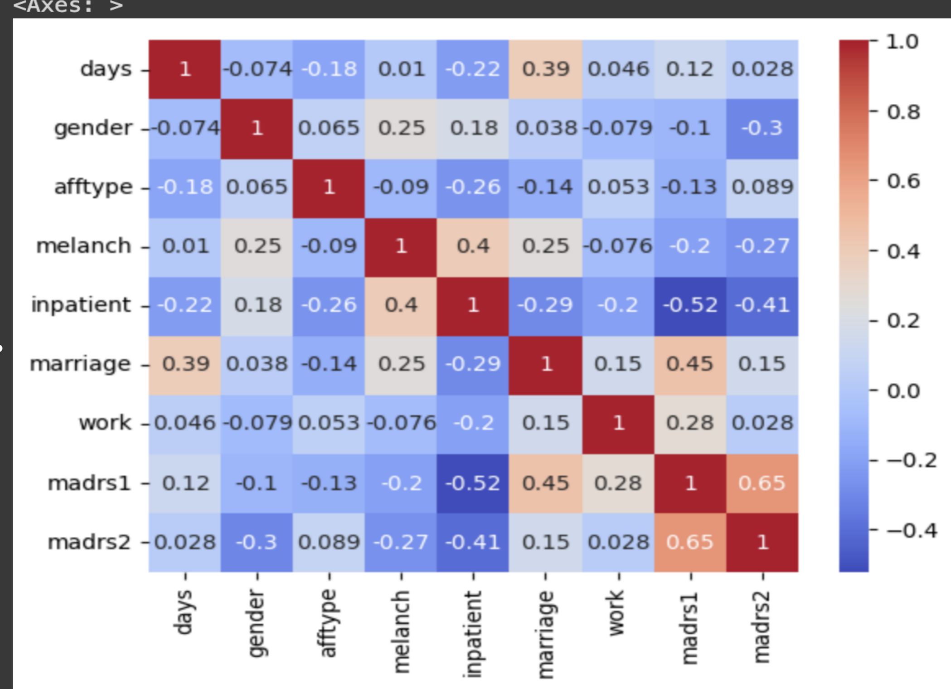

***Figure3.2.2: Correlation matrix***

**\*\*madrs1 is highly overall correlated with madrs2 and 5 other fields.**

**\*\*madrs2 is highly overall correlated with madrs1 and 4 other fields.**

**\*\*melanch is highly overall correlated with madrs1 .**

**\*\*inpatient is highly overall correlated with madrs1 and 2 other fields.**

**\*\*marriage is highly overall correlated with madrs1 and 2 other fields.**

**\*\*work is highly overall correlated with madrs1 and 2 other fields.**

**3.2.3 *Pre-processing of Data***

In order to build a machine learning model that is reliable and accurate, data pre-processing is essential. Results may be unreliable if the initial data isn't accurate or in the right format. As a result, pre-processing is done to change the data's format so that it meets the needs of the model.Various methods are used at this stage to deal with problems with the dataset, such as noise, duplication, and missing values. The data pre-processing pipeline must include the import of datasets, splitting them for training and testing, and attribute scaling.We ensure that the model can perform efficiently and produce more accurate predictions by carefully pre-processing the data. This preliminary phase considerably raises the model's Accuracy, making it more precise for Real-World Applications.

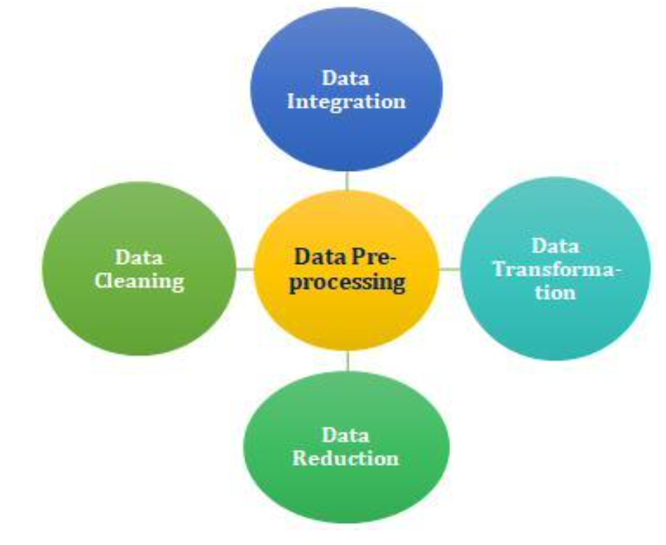

***Figure 3.2.3: Data Pre-processing***

**The various steps involved in data prepocessing are as follows:**

**1.Handling Missing Values:**

* **Imputation:**Fill missing values with the mean,median,mode or a custom value.
* **Deletion:**Remove or drop the rows or columns with missing values.
* **Advanced Imputation:** Use regression, k-Nearest Neighbors, or machine learning algorithms for imputation.

**2.Handling Noisy Data:**

* Determine and eliminate outliers with statistical techniques.
* To lessen noise, use smoothing methods like kernel smoothing or moving averages.

**3.Data Transformation:**

* **Normalisation** is the process of scaling numerical features to a predetermined range (e.g., z-score normalisation, Min-Max scaling).
* **Standardisation:** Convert the data so that the standard deviation is one and the mean is zero.
* **Log Transformation:** To deal with skewed distributions, take the values' logarithm.

**4.Selection of Attributes:**

* **Choose Relevant Features:** To select the most relevant features, apply feature importance techniques or domain knowledge.
* **Get Rid of Duplicate Features:** In order to decrease multicollinearity, get rid of highly correlated features.

**5.Discretization:**

Convert Continuous Features to Discrete: Group continuous values into bins or intervals.

Useful when the relationship between the variable and the target is non-linear.

**6.Concept Hierarchy Generation:**

* Create Hierarchies for Categorical Variables: Group similar categories into higher-level concepts.
* Enhances interpretability and reduces dimensionality.

**7.Data Reduction:**

* Principal Component Analysis (PCA): Reduce dimensionality while retaining as much variance as possible.
* t-Distributed Stochastic Neighbor Embedding (t-SNE): Useful for visualizing high-dimensional data in lower dimensions.

**8.Feature Selection:**

* **Filter Methods:** Use statistical tests or correlation coefficients to select features.
* **Wrapper Methods:** Use a model's performance to evaluate subsets of features (e.g., recursive feature elimination).
* **Embedded Methods:** Feature selection is incorporated into the training process (e.g., LASSO regression).

**9.Feature Extraction:**

* **PCA (Principal Component Analysis):**Reduces dimensionality while preserving the most important information.
* **Autoencoders:** Neural network-based technique for feature extraction.

**10.Handling Categorical Data:**

* **One-Hot Encoding:** Convert categorical variables into binary vectors.
* **Label Encoding:** Map categorical values to integer values.

**11.Handling Imbalanced Classes:**

* **Under-sampling and Over-sampling:** Balance the number of instances in each class.
* The **RandomOverSampler** is another oversampling technique provided by the imbalanced-learn library (imblearn). It randomly duplicates instances from the minority class to balance the class distribution.
* The **RandomUnderSampler** is an undersampling technique provided by the imbalanced-learn library (imblearn). It randomly removes instances from the majority class to balance the class distribution.
* **Synthetic Minority Over-sampling Technique (SMOTE):** Generate synthetic samples for the minority class.

**12.Data Augmentation:**

* Generate new training samples by applying transformations (e.g., rotation, flipping) to existing samples.
* Commonly used in image data.

**13.Text Data Preprocessing:**

* **Tokenization:** Break text into individual words or tokens.
* **Removing Stop Words:** Eliminate common words that do not contribute much to the meaning.
* **Stemming and Lemmatization:** Reduce words to their base or root form.

**14.Time Series Data Preprocessing:**

* **Resampling:** Change the frequency of the time series data.
* **Rolling Windows:** Compute statistics over a moving window of data.

**15.Handling Duplicate Data:**Remove or deduplicate identical or highly similar rows.

**16.Data Splitting:**Split the dataset into training and testing sets for model evaluation.

**17.Handling Inconsistent Data:**Standardize units of measurement and ensure consistency in data formats.

**3.2.4 Prediction of level of depression , depression types of patients and many more**

We used a wide range of machine learning techniques to pursue classification tasks in order to attain the best outcomes. These include Logistic Regression, Naive Bayes, AdaBoost, Random Trees and XGBoost as well as Decision Trees, Support Vector Machines (SVM),Gradient Boosting and Logistic Regression. Every algorithm brings unique advantages and traits to the table.We conduct a thorough comparison examination of these algorithms to assure the best performance.We identified the approach with the highest accuracy for all seven submodel through this evaluation.We can safely design a prediction system that excels in accuracy and dependability and is well-equipped to address the problem of patients who suffered from depression and beyond by carefully choosing the most appropriate algorithm for each submodel.

**3.3 Machine Learning Algorithm**

***Various Machine Learning Algorithms that i have used in this project are as follows:***

**1.Decision tree:**A supervised machine learning algorithm called a decision tree is used for both regression and classification problems. In this model, which resembles a tree, every node denotes a decision made in response to a particular feature, and every branch denotes the result of that decision. Decision trees offer distinct insights into the decision-making process and are effective tools for data exploration and modelling.the Decision Tree classifier serves as a pivotal component for predicting and understanding the depression status of individuals based on wearable sensor data.

**Key Concepts:**

* **Node:**In a Decision Tree, a node represents a decision point based on a feature.The top node is the root node, and subsequent nodes are branches leading to leaves.
* **Feature Split:**At each node, a decision is made by splitting the data based on a selected feature.The goal is to choose the feature that best separates the data, often measured by criteria like Gini impurity or information gain.
* **Leaf Node:**Terminal nodes at the ends of branches are called leaf nodes.Each leaf node corresponds to a class label (in classification) or a predicted value (in regression).
* **Entropy and Information Gain:**Entropy measures the impurity or disorder in a set of data.Information Gain is the reduction in entropy achieved by splitting the data based on a particular feature.Decision Trees aim to maximize Information Gain.
* **Gini Impurity:**Gini Impurity is another measure of impurity used in Decision Trees.It represents the probability of incorrectly classifying a randomly chosen element if it were randomly labeled according to the distribution of labels in the set.

**Advantages:**

1. **Interpretability:**Decision Trees are easy to understand and interpret, making them suitable for conveying decision logic to non-experts.
2. **Handling Non-linearity:**Decision Trees can model complex, non-linear relationships in the data without the need for complex mathematical equations.
3. **Feature Importance:**The algorithm provides a natural way to identify the importance of different features in predicting the target variable.

**Challenges**:

1. **Overfitting:**Decision Trees are prone to overfitting, capturing noise in the training data.Techniques like pruning are used to mitigate overfitting.

2. **Instability:**Small changes in the data can result in a completely different tree structure.

* Techniques like ensemble methods (e.g., Random Forests) can enhance stability.

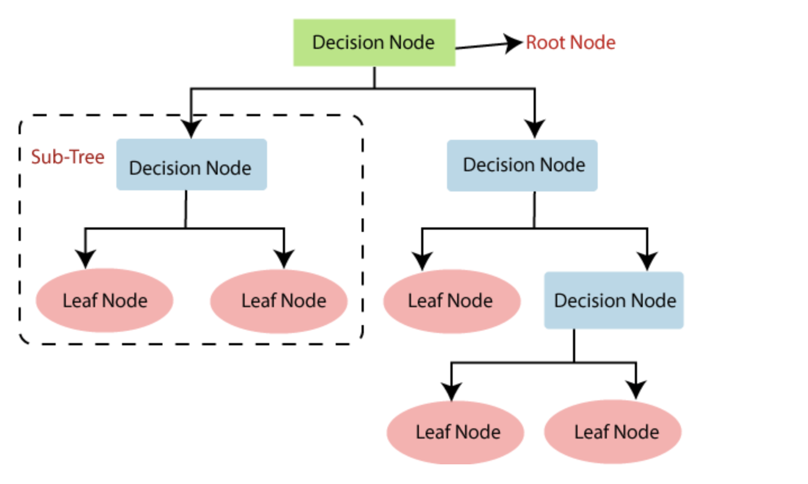

**Figure3.3.1 DecisionTree Algorithm**

**2.*Random Forest*:**One of the most potent and well-known machine learning algorithms For Classification and Regression applications is Random Forest, an ensemble learning technique based on decision trees. Random Forest is an ensemble learning algorithm that combines the predictive power of multiple decision trees to enhance classification accuracy and robustness. In the context of your depression classification project, Random Forest classifiers offer a sophisticated approach to leverage wearable sensor data for precise and reliable depression status predictions.

**Key Concepts:**

* **Ensemble of Decision Trees:**Random Forest is an ensemble of decision trees, each trained on a subset of the dataset using bootstrapped samples.The combination of multiple trees mitigates overfitting and provides a more robust and accurate prediction.
* **Random Feature Selection:**At each split in a decision tree, Random Forest considers only a random subset of features.This randomness enhances diversity among the trees, contributing to better generalization.
* **Voting Mechanism:**For classification tasks, each tree "votes" for a class, and the class with the majority of votes is assigned as the final prediction.

This mechanism improves the overall reliability of the model.

**Advantages in Mental Health Monitoring:**

* **Improved Accuracy:**Random Forest tends to deliver higher accuracy compared to individual decision trees, crucial for reliable depression status predictions.
* **Feature Importance Analysis:**The algorithm inherently provides a measure of feature importance, aiding in identifying the most influential activity patterns contributing to depression classification.
* **Handling Non-linearity:**Random Forest can capture complex, non-linear relationships in the data, making it well-suited for modeling the intricate nature of mental health patterns.

**Challenges in Depression Classification:**

* **Interpretability:**While Random Forests provide high accuracy, the ensemble nature can make it less interpretable compared to a single decision tree.
* **Computational Cost:**Training and evaluating Random Forests can be computationally expensive, especially with large datasets, though the benefits often outweigh the costs.

**Conclusion:**

In the specific context of your depression classification project, Random Forest classifiers offer an advanced and robust solution for leveraging wearable sensor data. Their ensemble nature, coupled with random feature selection, enhances accuracy and provides valuable insights into the intricate relationships between activity patterns and depression status. Understanding the strengths and considerations of Random Forests is crucial for optimizing their application in mental health analysis.

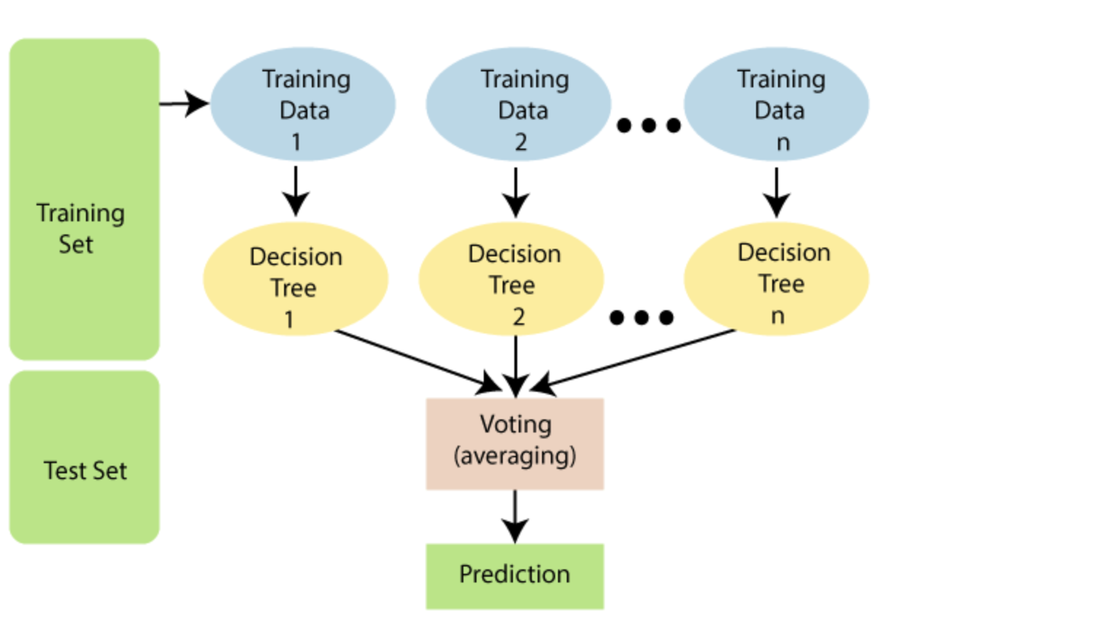

**Figure3.3.2 RandomForest Algorithm**

**3.4 *Machine Learning Interfaces***

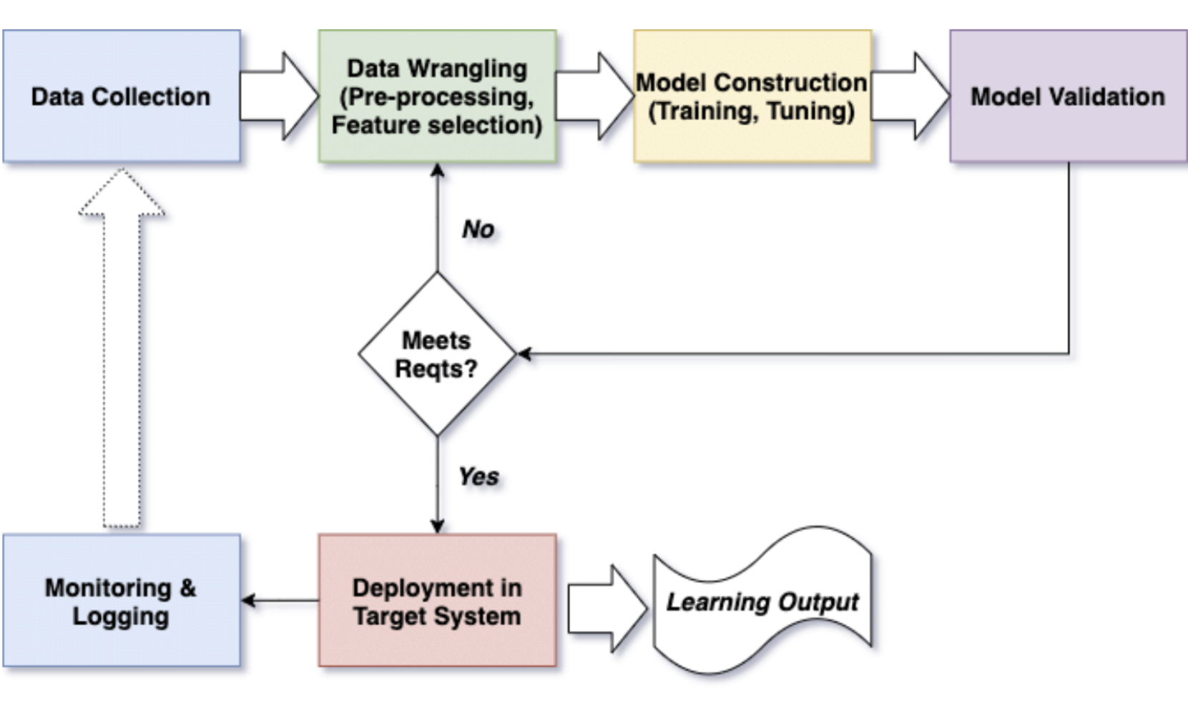

***figure3.4:Block diagram of machine learning based system***

***3.5 A Machine Learning Architecture for depression detection***

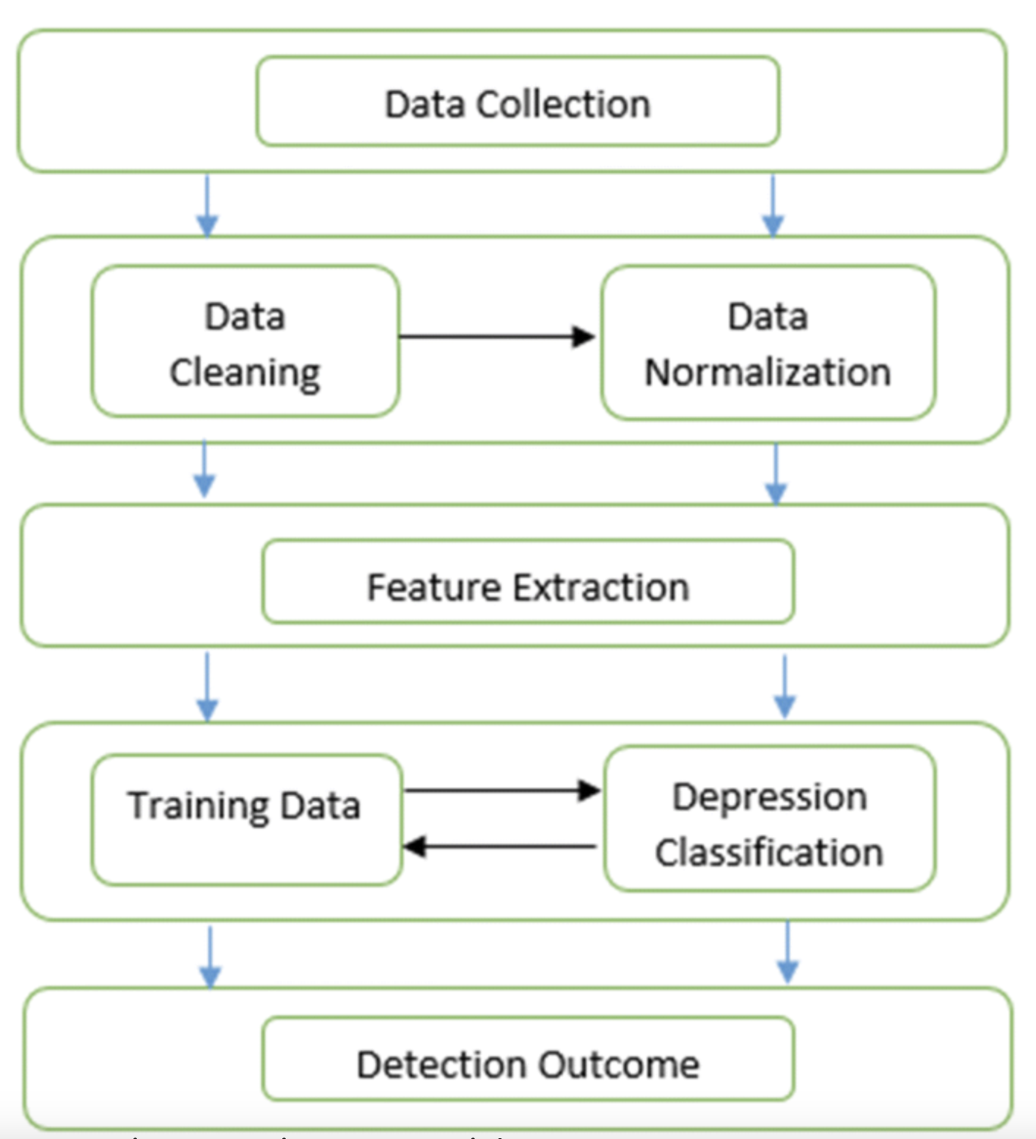 ***figure 3.5:A Machine Learning Architecture for depression detection***

**CHAPTER 4**

**EXPERIMENTALS ANALYSIS**

**4.1 *SYSTEMS CONFIGURATION*S**

***4.1.1 Hardwares Requirements:***

Rams :Min 4GB

Processers :Any Updated Processer

Hard Disk(HD) :Minimum 110GB

***4.1.2 Software requirements:***

Technology :Python3. 7

Operating System(OS) :Macos_families

IDE :Jupyter_notebook

***4.2 Sample Code***

***4.2.1 import the libraries***

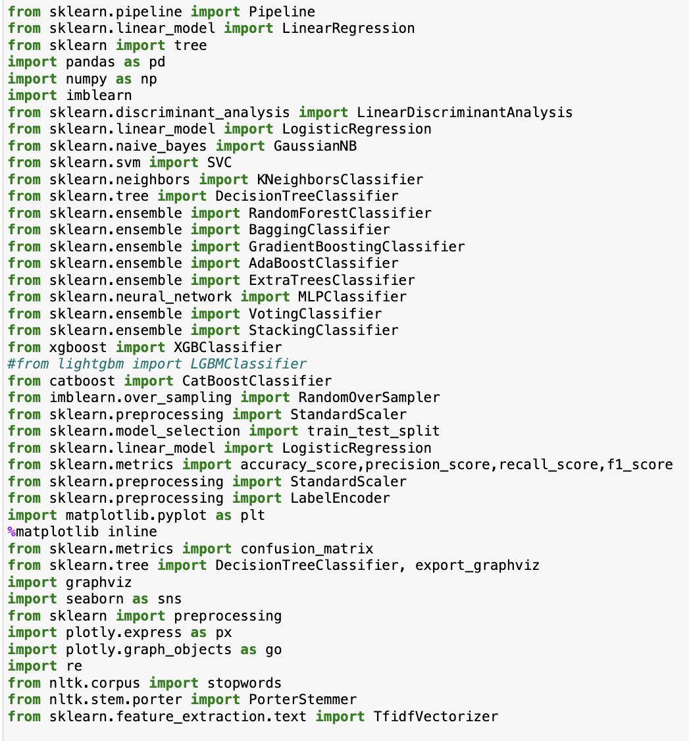

**4.2.2 *Importing Dataset***

kk = pd.read_csv("scores.csv")

**4.2.3 *Data preprocessing***

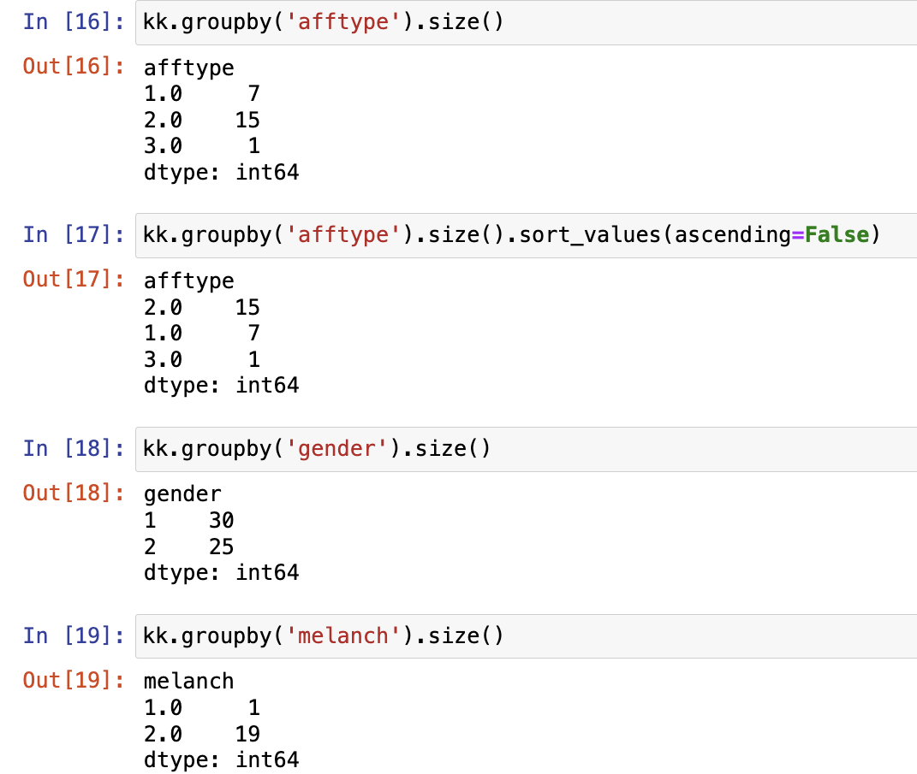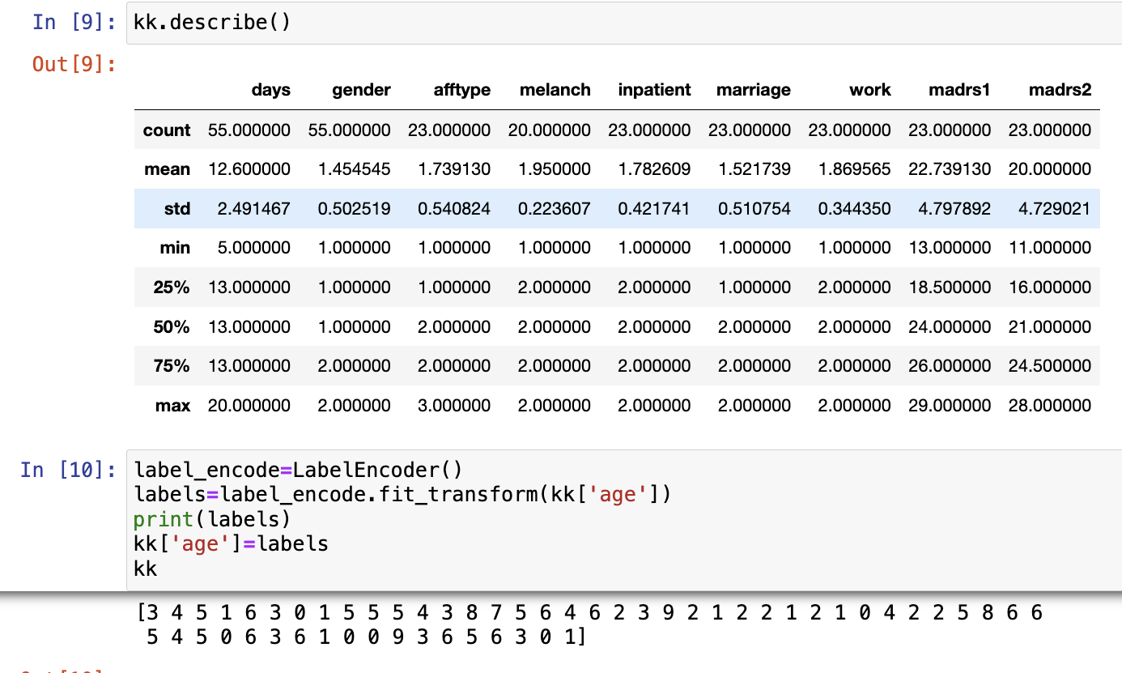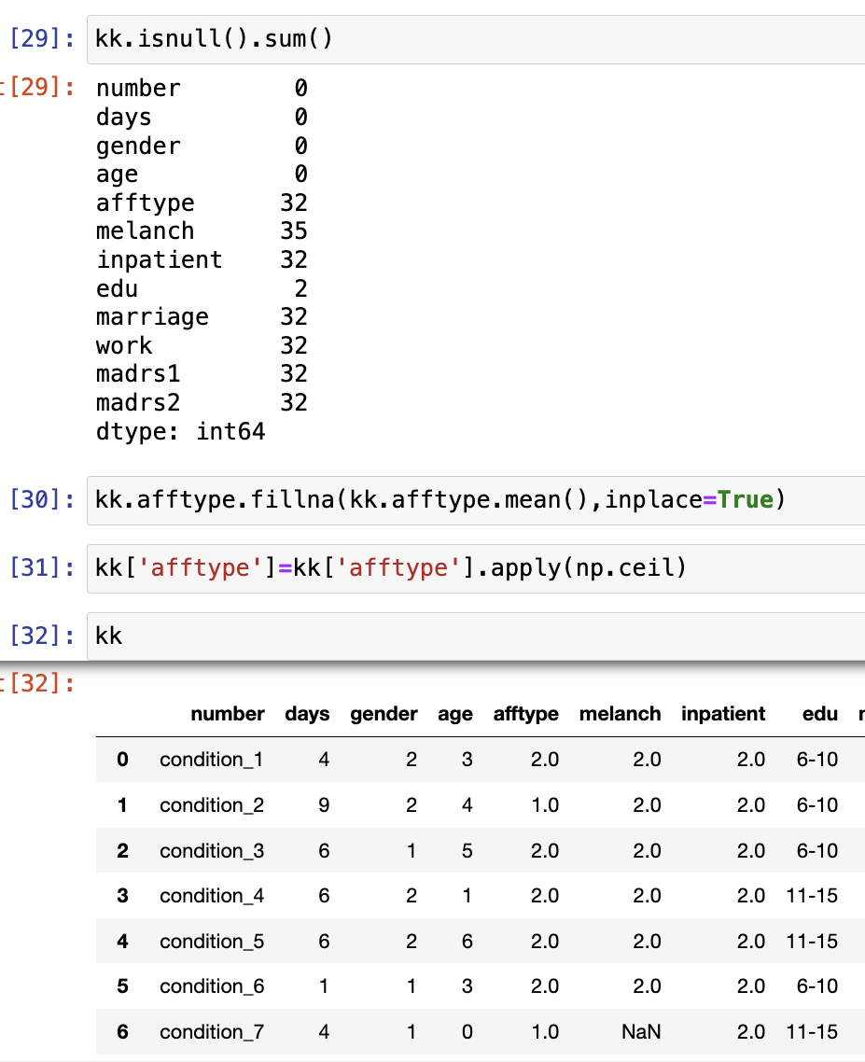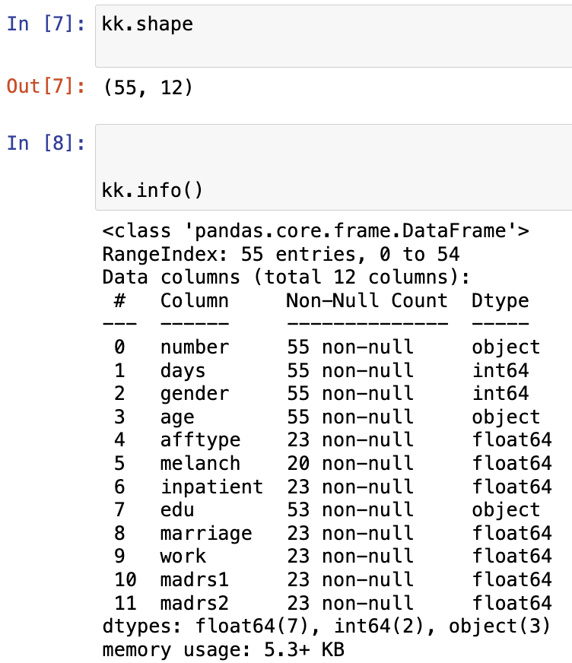

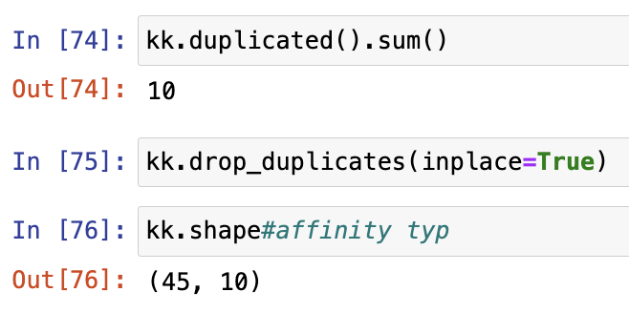

***Figure4.2.3:Screenshot of code of data preprocessing Steps***

***4.2.4 Data Visualization***

Data visualization is a critical aspect of data analysis and machine learning. It involves representing data graphically to help uncover patterns, trends, and insights that may not be apparent in raw data. Python offers several libraries like matplotlib,seaborn for creating various types of visualizations.

**#visualizing the features**

for columns in kk:

sns.displot(x=columns,data=kk)

ax

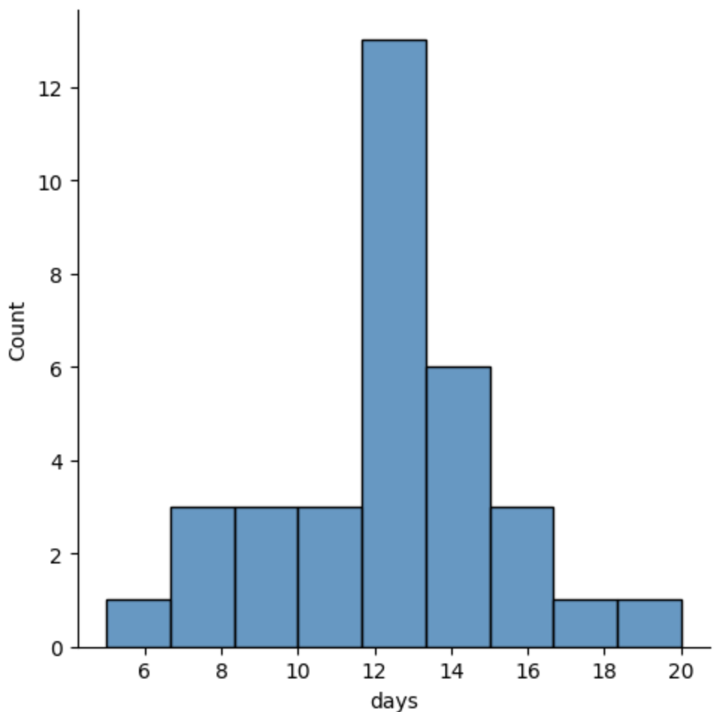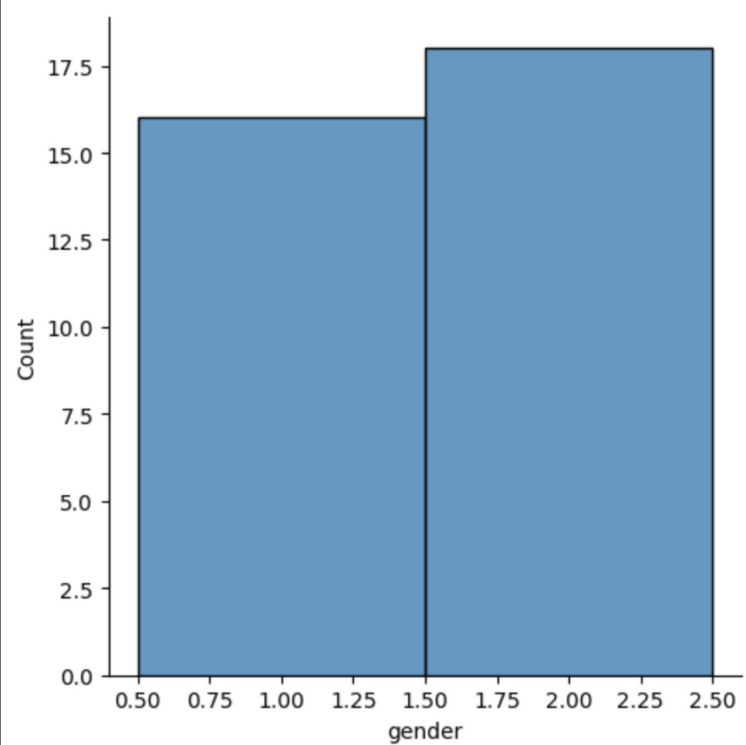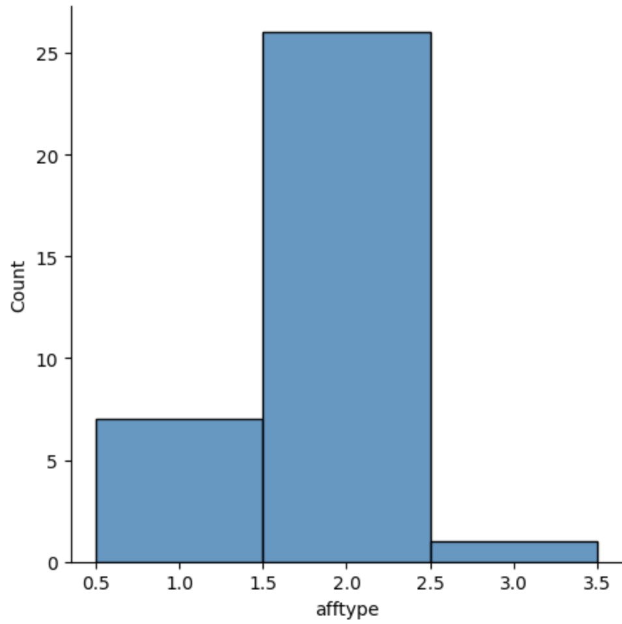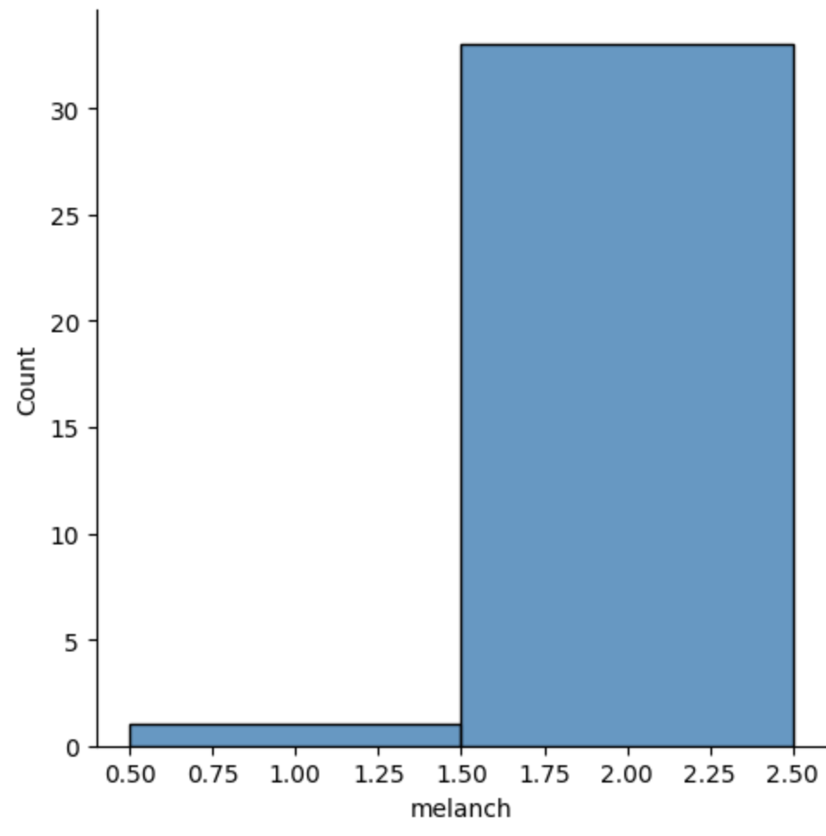

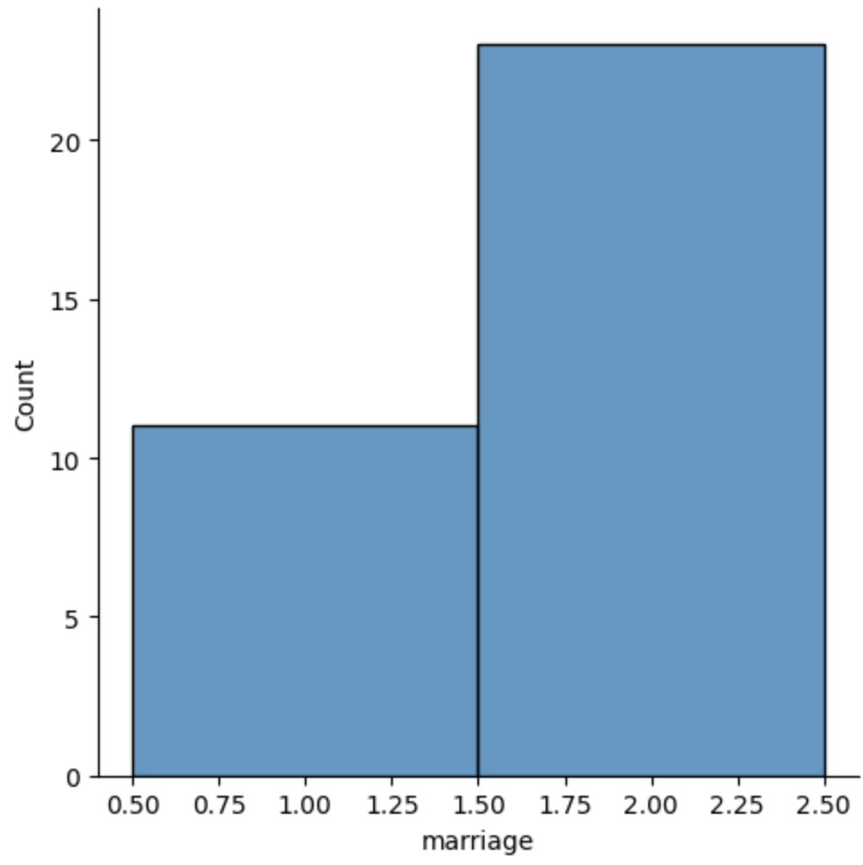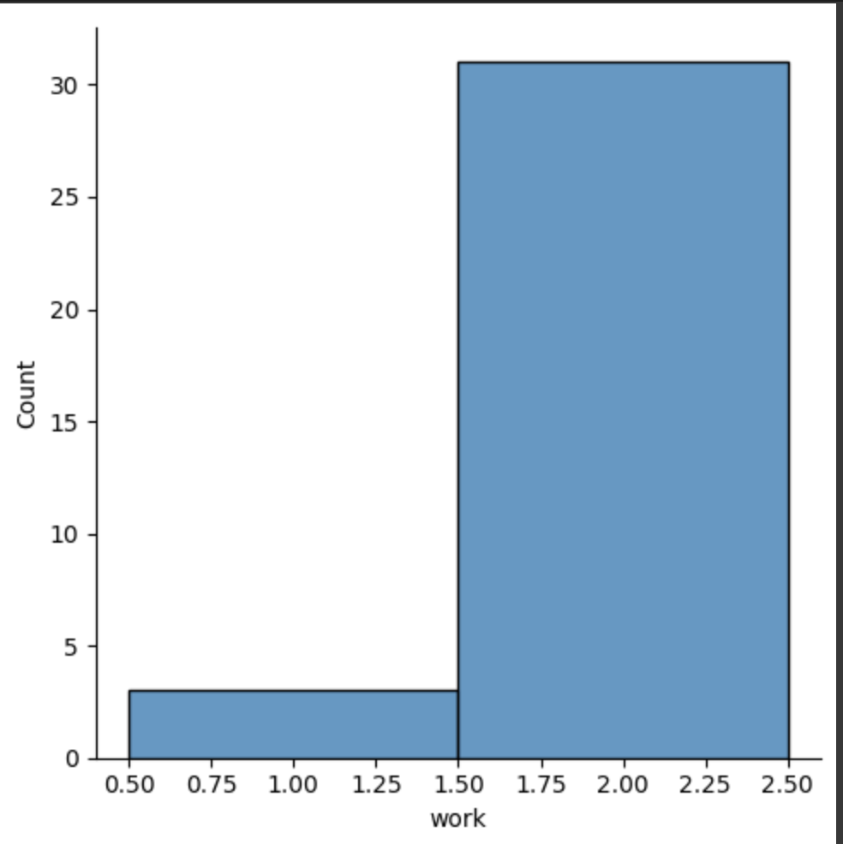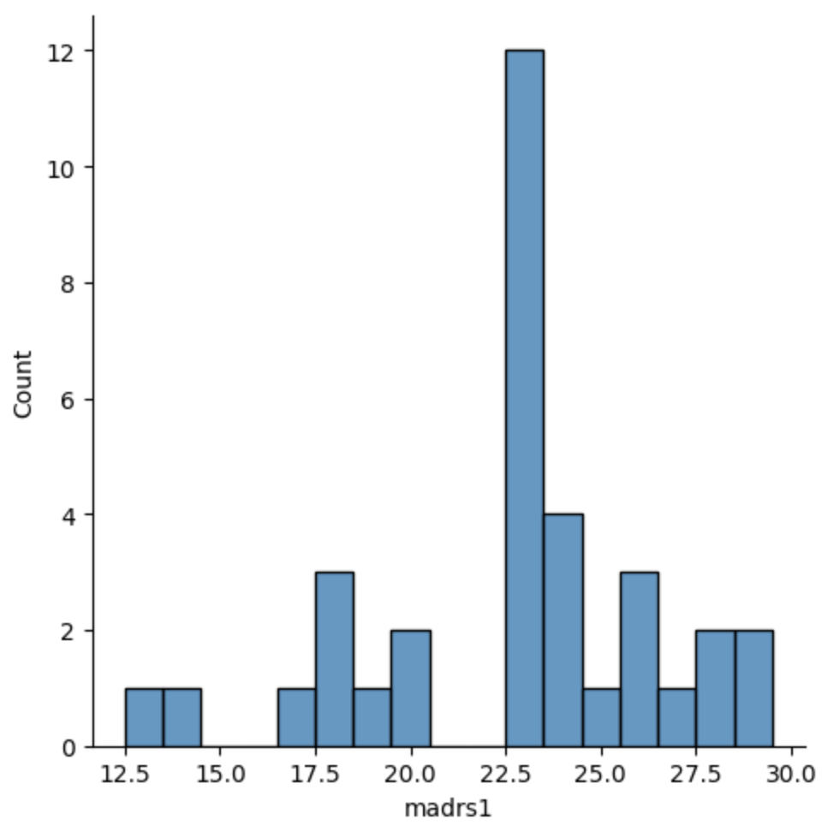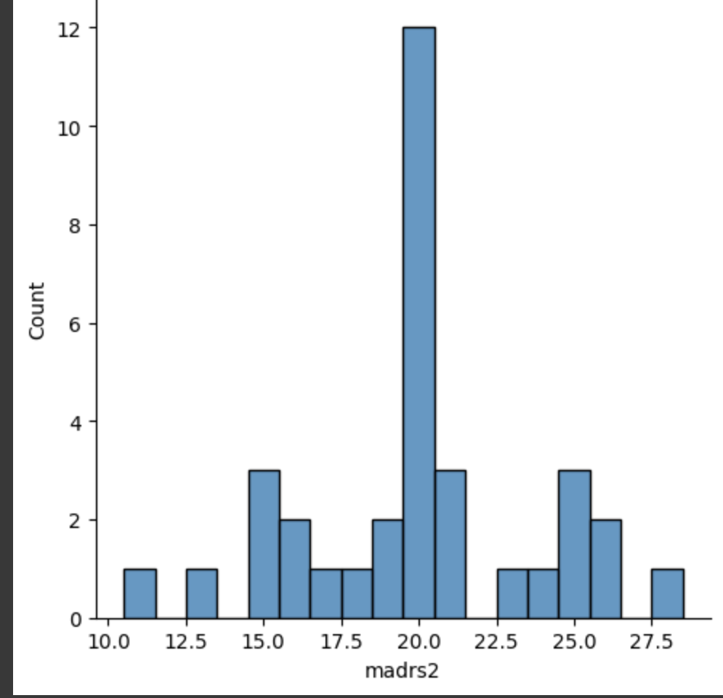

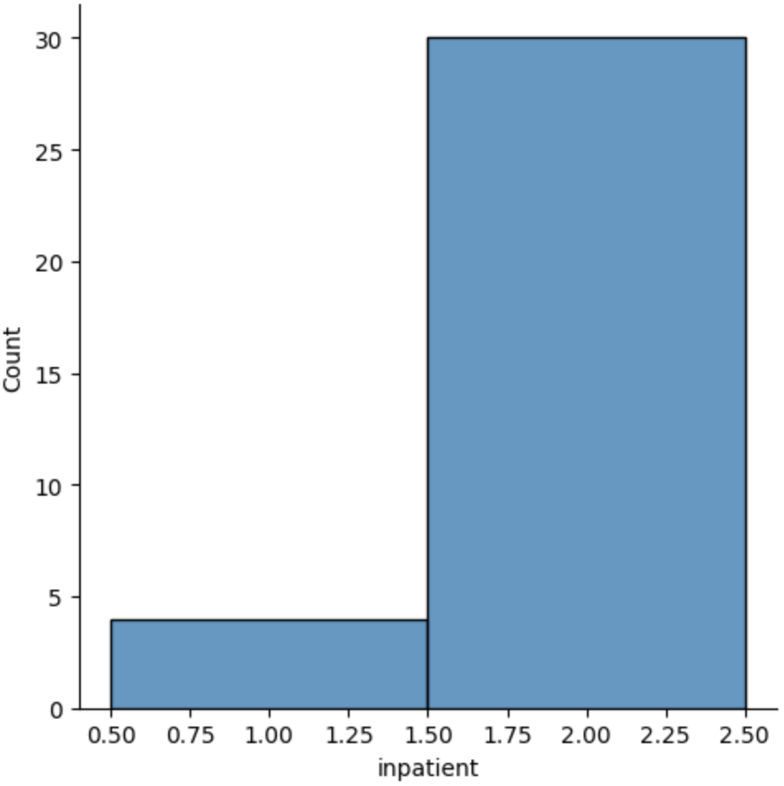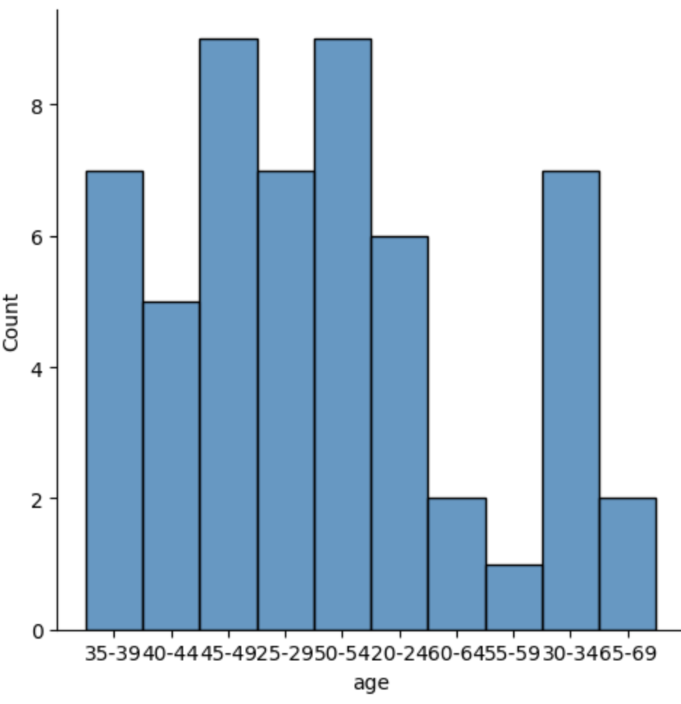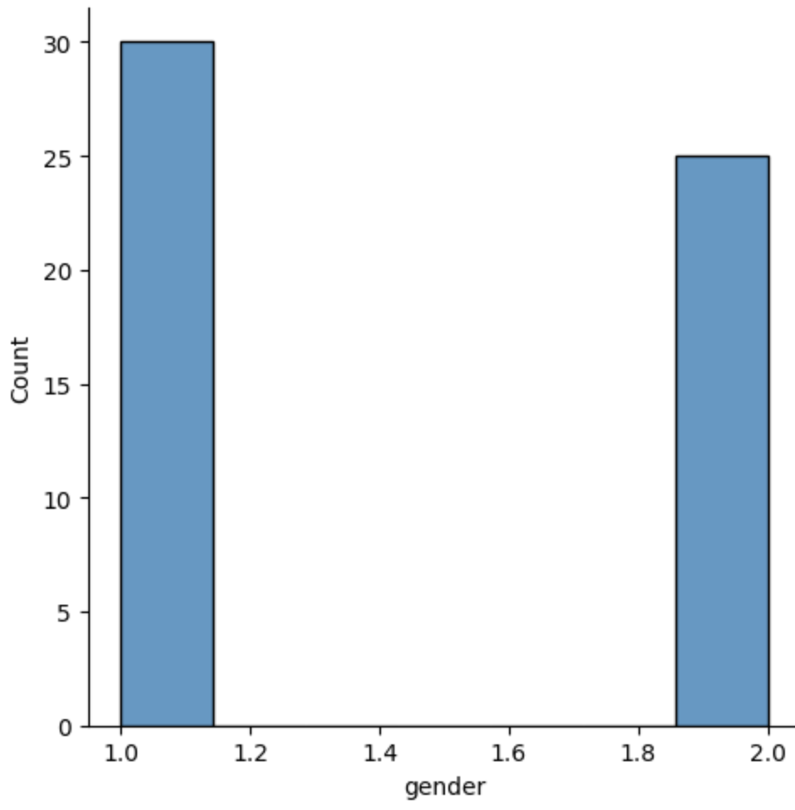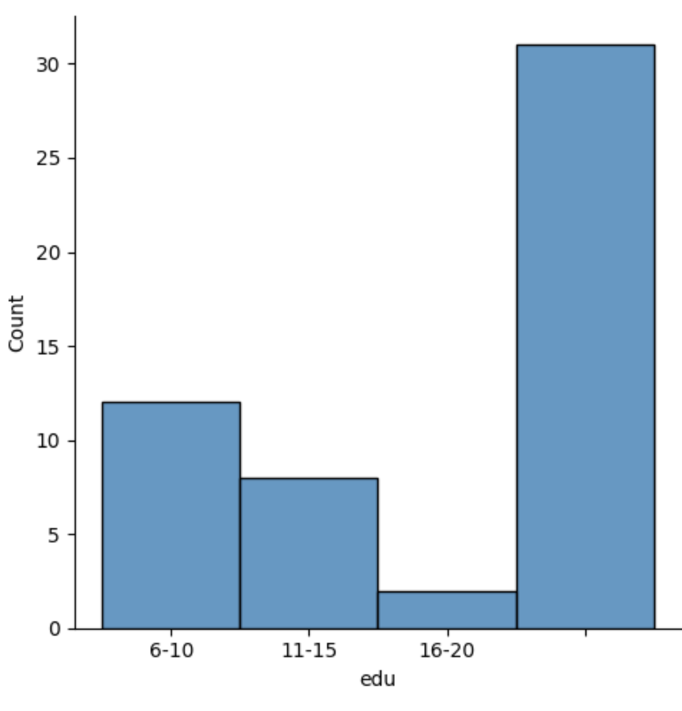

***figure 4.2.4:Data Visualization***

kk.head()

***4.2.5 Cross-Validation***

***4.2.6 Accurate Algorithm******Selection***

#USE DIFFERENT DIFFERENT MODEL TO CHECK THE ACCURACY(TRAINING AND TESTING ACCURACY).#I WILL USE ONLY THOSE MODEL FOR FURTHER STEP(TRAINING STAGE)WHICH GIVE PROPER VALUE OF ACCURACY#BECAUSE THE MODEL WHICH GIVE PROPER ACCURACY CAN PREDICT THE RESULT IN BETTER WAY

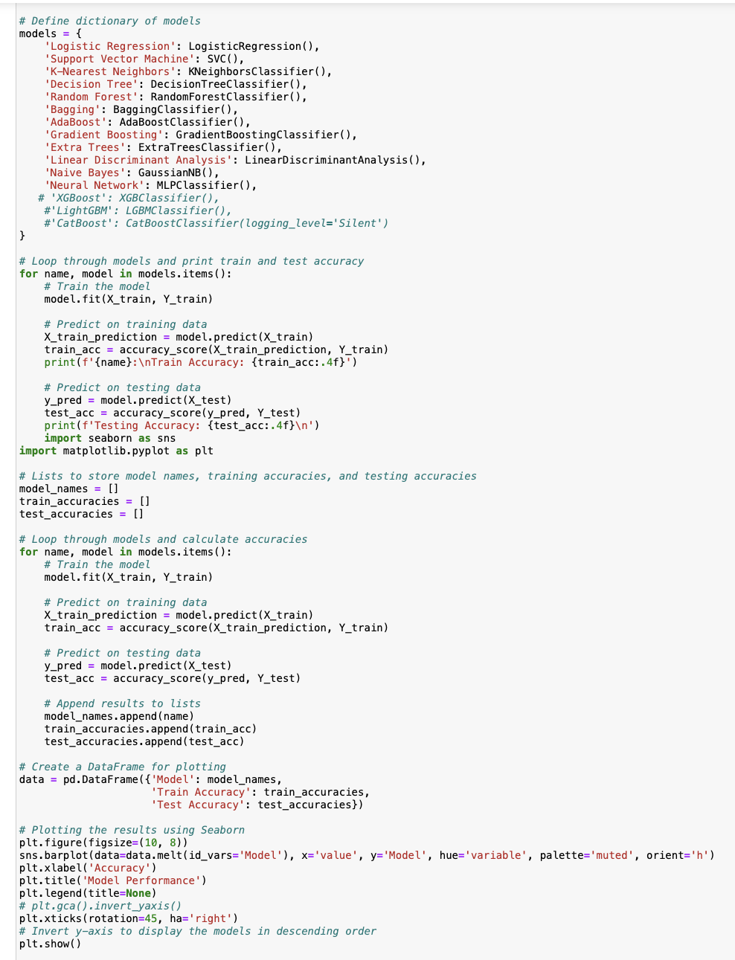

***4.2.7 Model training and testing***

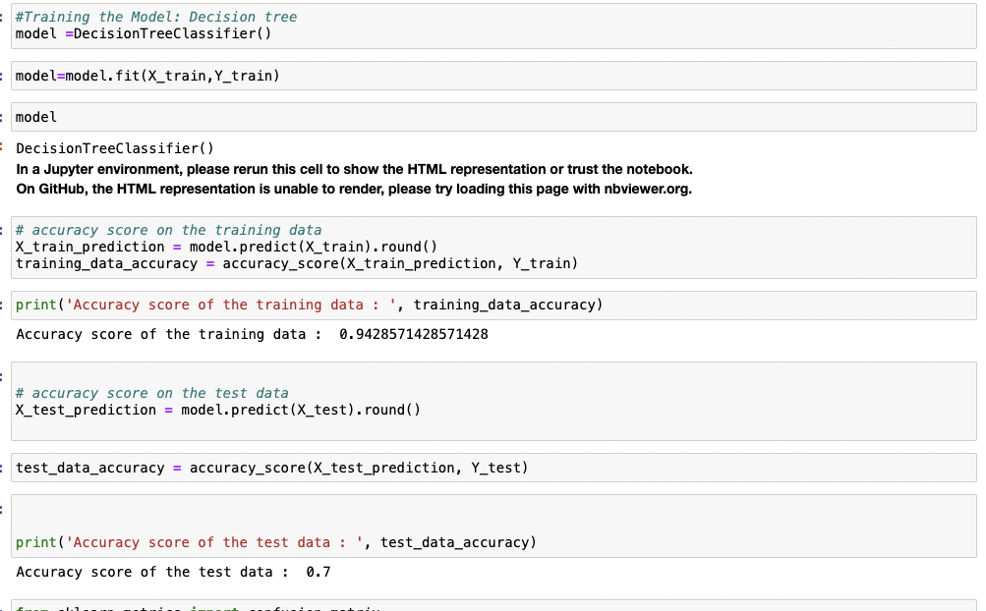

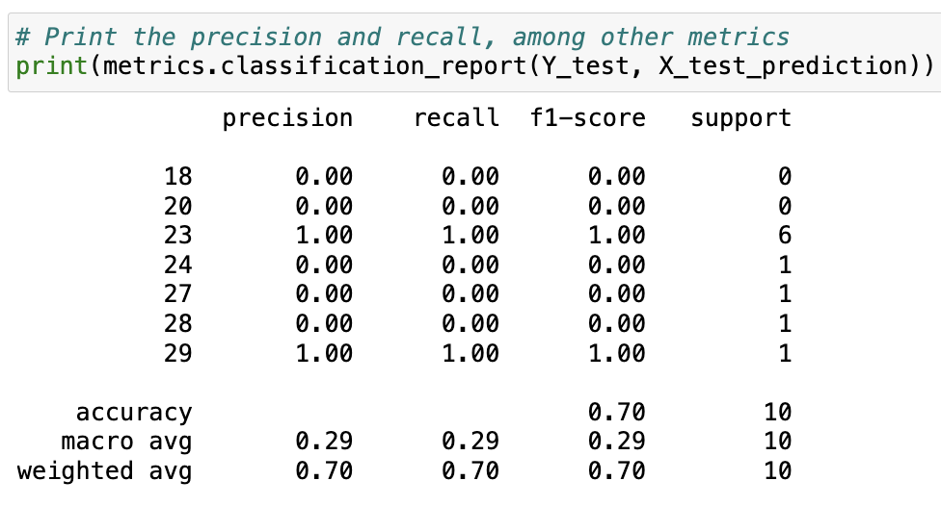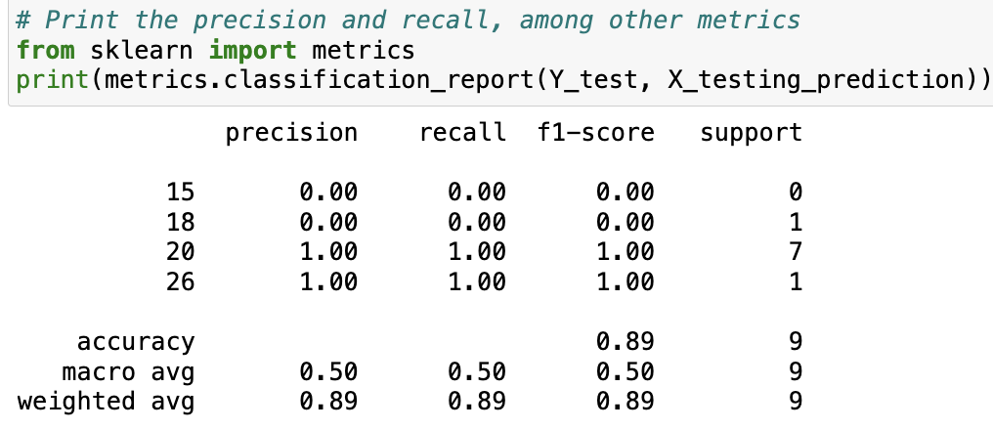

**model no 1 model 2**

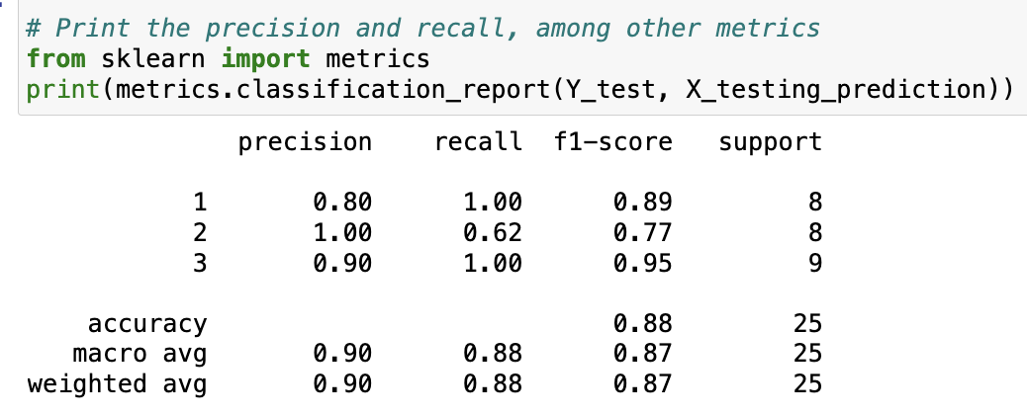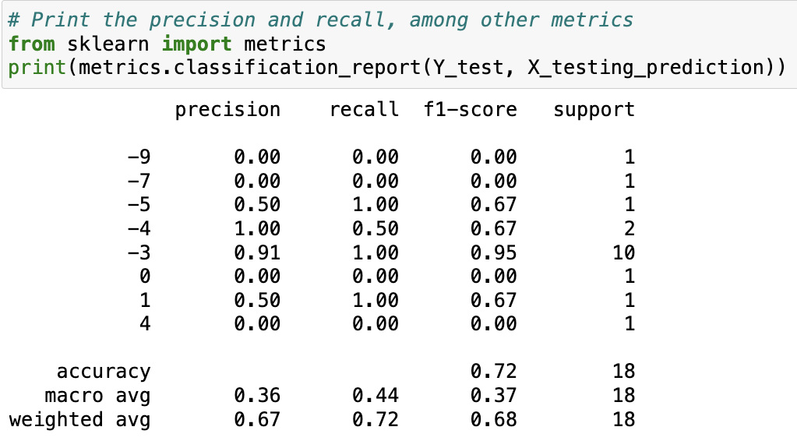***model no 3 model no 4***

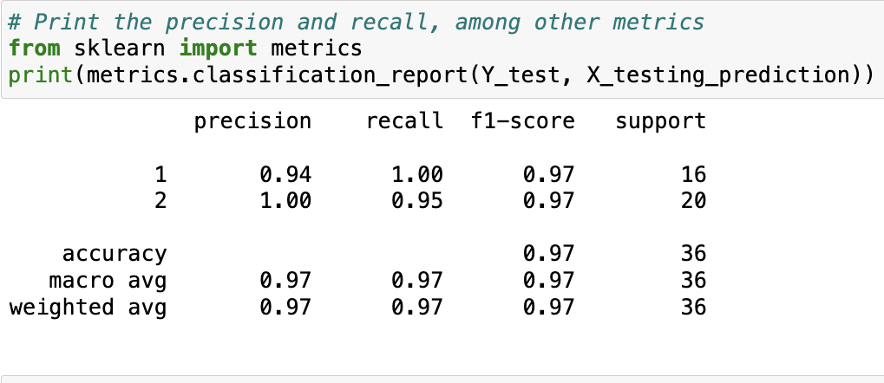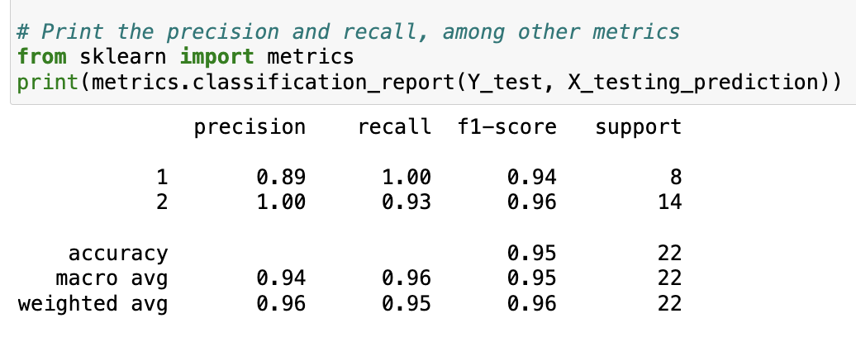

***model no 5 model no 6***

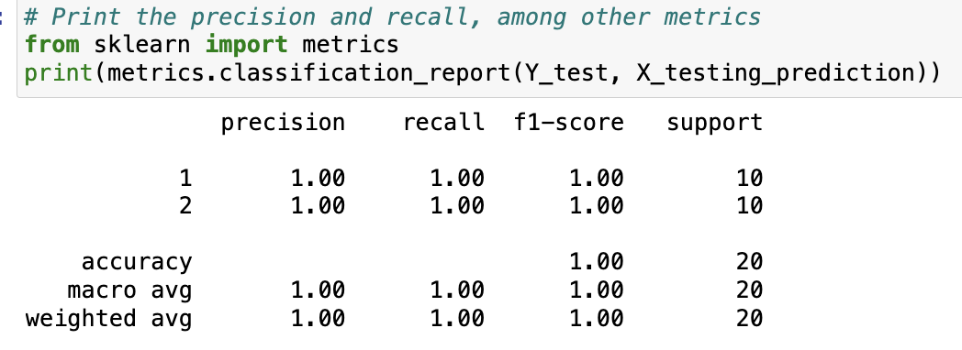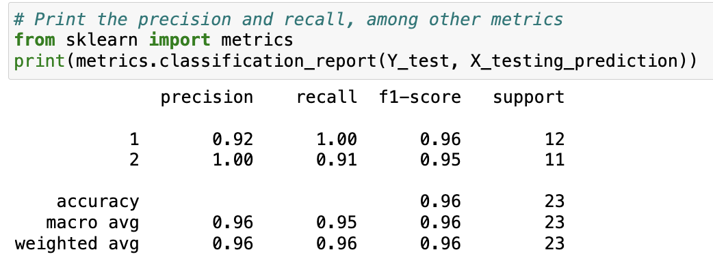 **model no 7 model no 8**

***Figure 4.2.7:performance measure parameters***

**\*model no 1: “**Create Machines Learning model for Predicting the MADRS1 score of persons/patients and on the basis of that score signify the level of depression in person/patients.”

**\*model no 2: “**Create Machines Learning model for Predicting the MADRS1 score of persons/patients and on the basis of that score signify the level of depression in person/patients.”

**\*model no 3:“**Machine Learning Classification of Depression Types: Differentiating Bipolar II, Unipolar Depressive, and Bipolar I Disorders for Personalized Treatment Strategies”.

**\*model no 4:“**Predicting Treatment Outcomes in Depression: A Machine Learning Approach for Assessing Patient Improvement”

**\*model no 5*:“*** Applying machine learning classification models to classify a patient's condition as melancholic or non-melancholic.”

**\*model no 6*:“*** Utilizing machine learning classification models to classify a patient's work status (1: working or studying, 2: unemployed/sick leave/pension).”

**\*model no 7:*“*** Utilizing machine learning classification models to classify a patient's patient's marital status (1: married or cohabiting, 2: single).”

**\*model no 8:*“*** Using machine learning classification models determine whether a patient is an inpatient or outpatient.”

***4.2.8 Making a Predictive System***

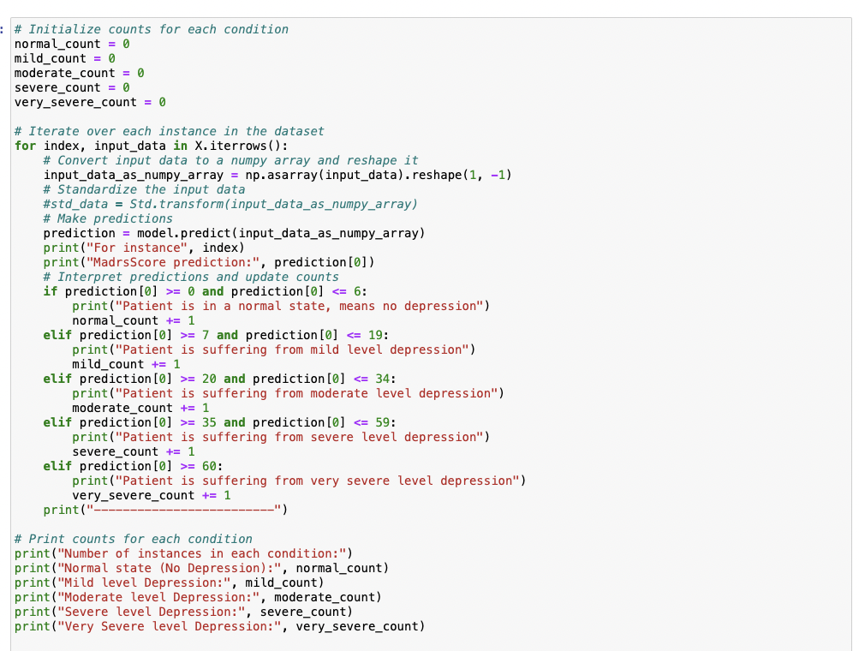

***4.3 PERFORMANCE ANALYSIS***

Performance analysis is a vital step in determining the precision and efficacy of a machine learning model for predicting agricultural output in India. Through a comparison of the model's predictions and actual crop production data, this analysis seeks to evaluate the model's effectiveness. Various crucial performance measurements and techniques are used to evaluate the model's effectiveness, including:

1.**Area Under the Receiver Operating Characteristic (ROC-AUC):**Measures the area under the ROC curve, which plots the true positive rate against the false positive rate at various thresholds.

2.**Accuracy**- In order to assess a model's overall efficacy in machine learning, accuracy is a fundamental performance metric that is used. It evaluates the model's accuracy in terms of the total number of predictions and the fraction of correct predictions.The following formula is used to determine accuracy:

Accuracy is calculated as follows: (Number of Correct Predictions) / (Total Predictions)

3.**Confusion Matrix**- In particular for classification tasks, a confusion matrix is a tabular representation used to assess how well a machine learning model performs. It offers a thorough description of how the model's forecasts stack up against the actual ground truth for various classes or categories. ***Figure 4.3.3:Confusion matrix***

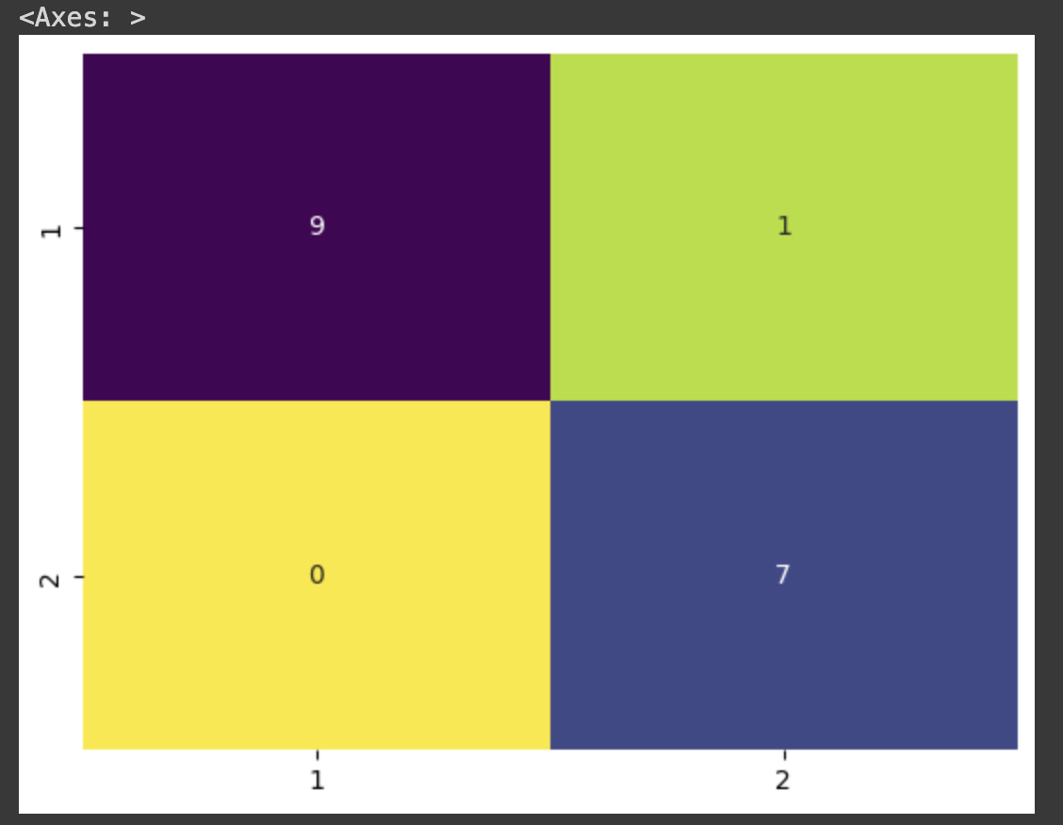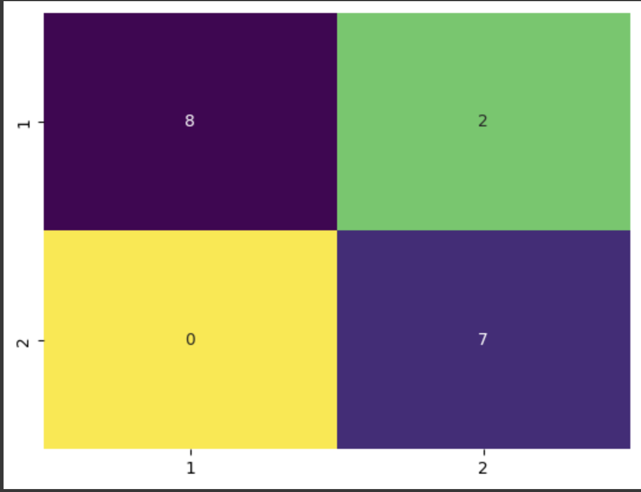

**4.Correlation Matrix**: For feature selection in machine learning, the correlation matrix is employed. It symbolizes the interdependence of several traits.



***Figure 4.3.4:Correlation Matrix***

**5.F1 Score:** In binary classification problems, the F1 score is a performance indicator frequently used to assess the harmony between recall and precision. It is especially helpful when dealing with imbalanced datasets since it provides a single value that accounts for both false positives and false negatives.The following formula is used to determine the F1 score:

F1 Score is equal to **2 * (Precision * Recall) / (Precision + Recall).**

**6.Recall:**In binary classification problems, recall—also referred to as sensitivity or true positive rate—is a performance indicator. It assesses how well a machine learning model can distinguish between the true positive examples contained in the dataset and the positive instances (i.e., instances of the target class).

Recall is calculated using the following formula:

Recall is defined as **True Positives / (False Negatives + True Positives).**

**7.Precision:**Precision is a performance metric used in binary classification tasks to evaluate the accuracy of positive predictions made by a machine learning model. It assessesthe proportion of true positive predictions out of all the positive predictions made by the model.The formula to calculate precision is as follows:

**Precision = True Positives / (True Positives + False Positives)**

**8.Matthews Correlation Coefficient (MCC):**Measures the correlation between observed and predicted binary classifications. It takes into account true and false positives and negatives.

**Formula: (TP * TN - FP * FN) / sqrt((TP + FP) * (TP + FN) * (TN + FP) * (TN + FN))**

**4.4 PERFORMANCES MEASURES**

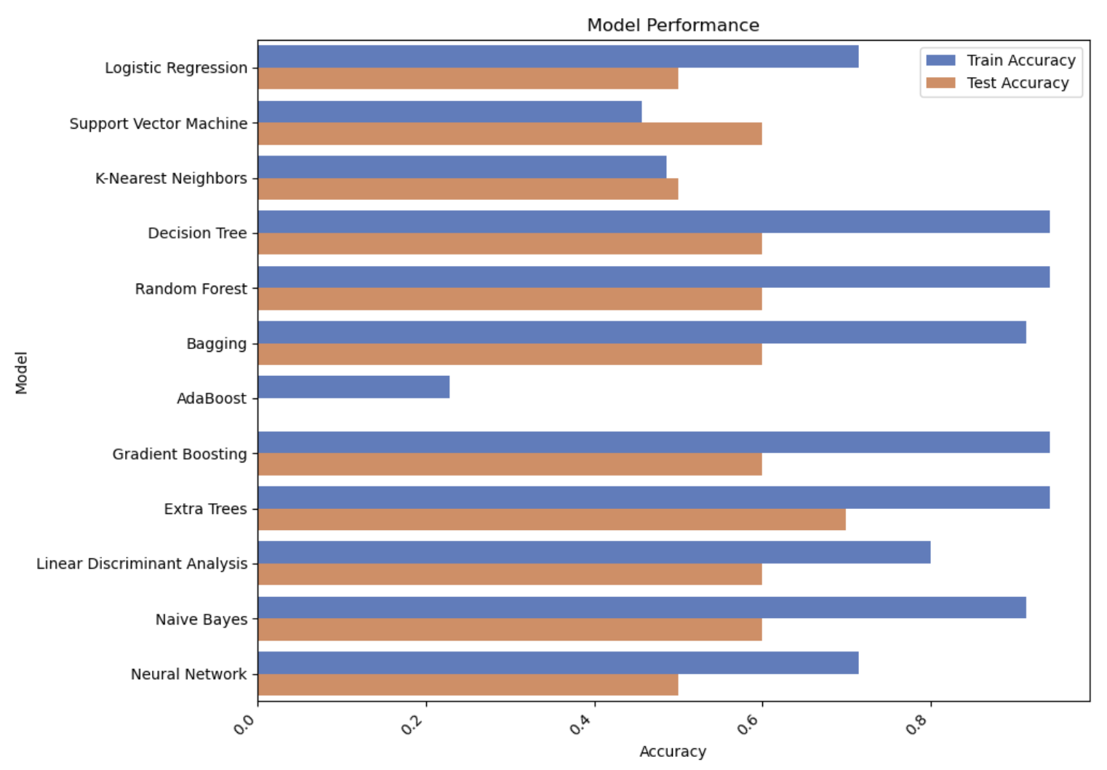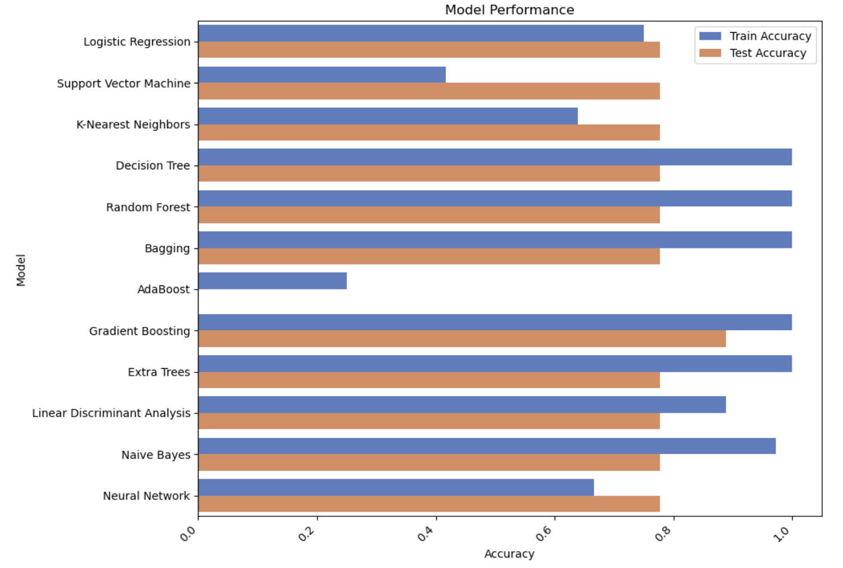

***model no 1 model no 2***

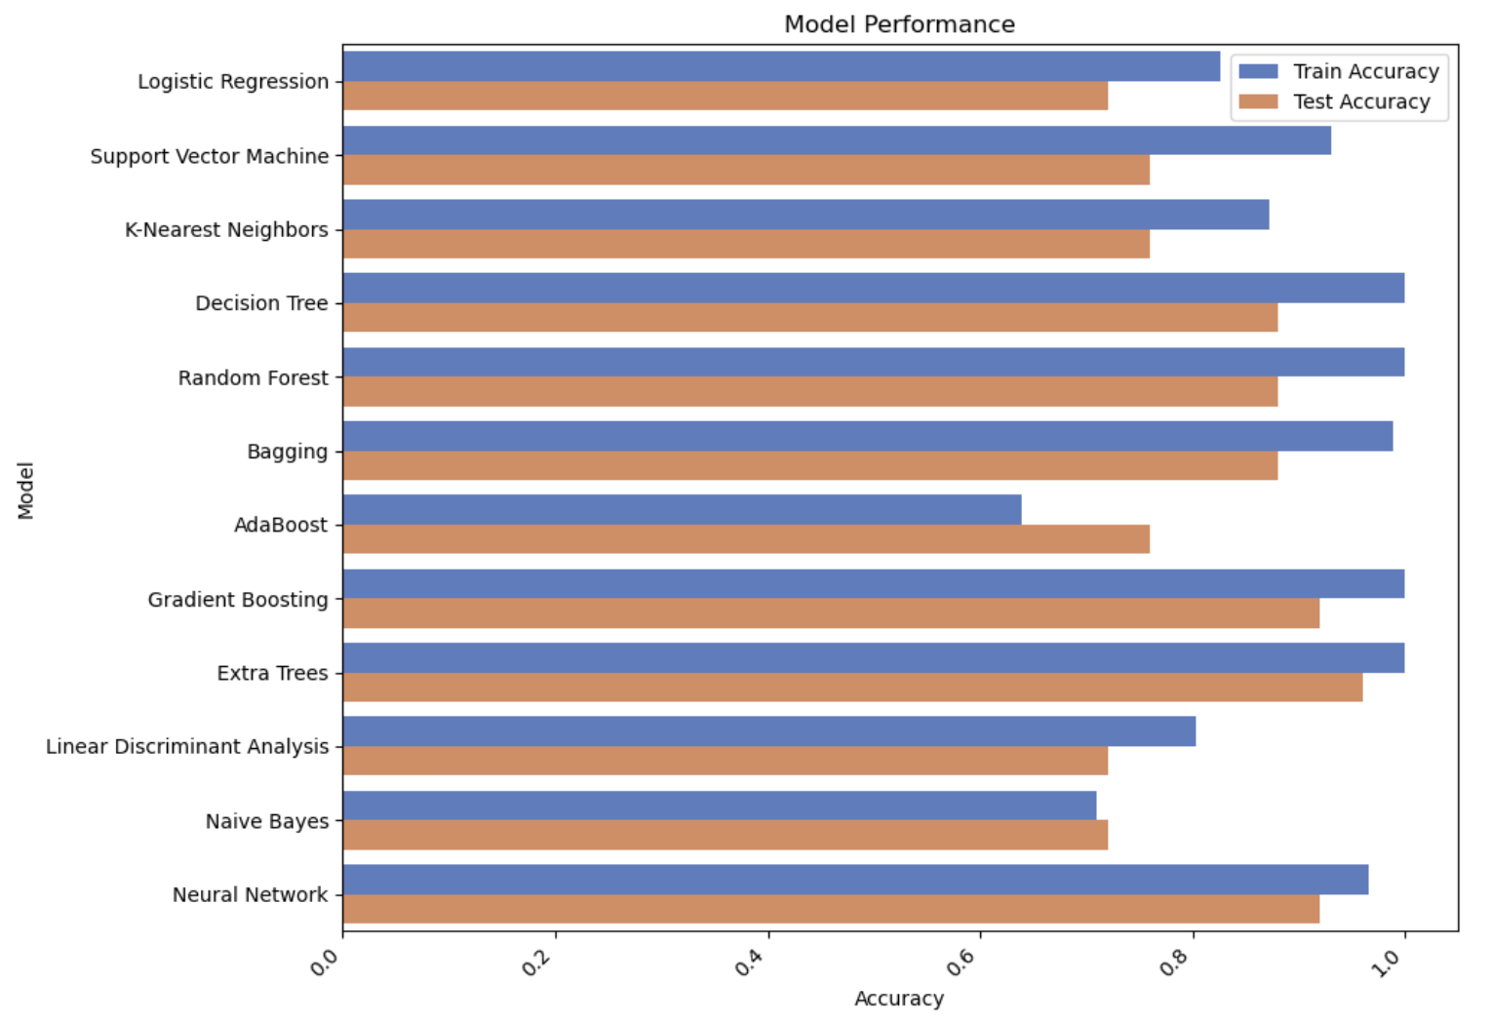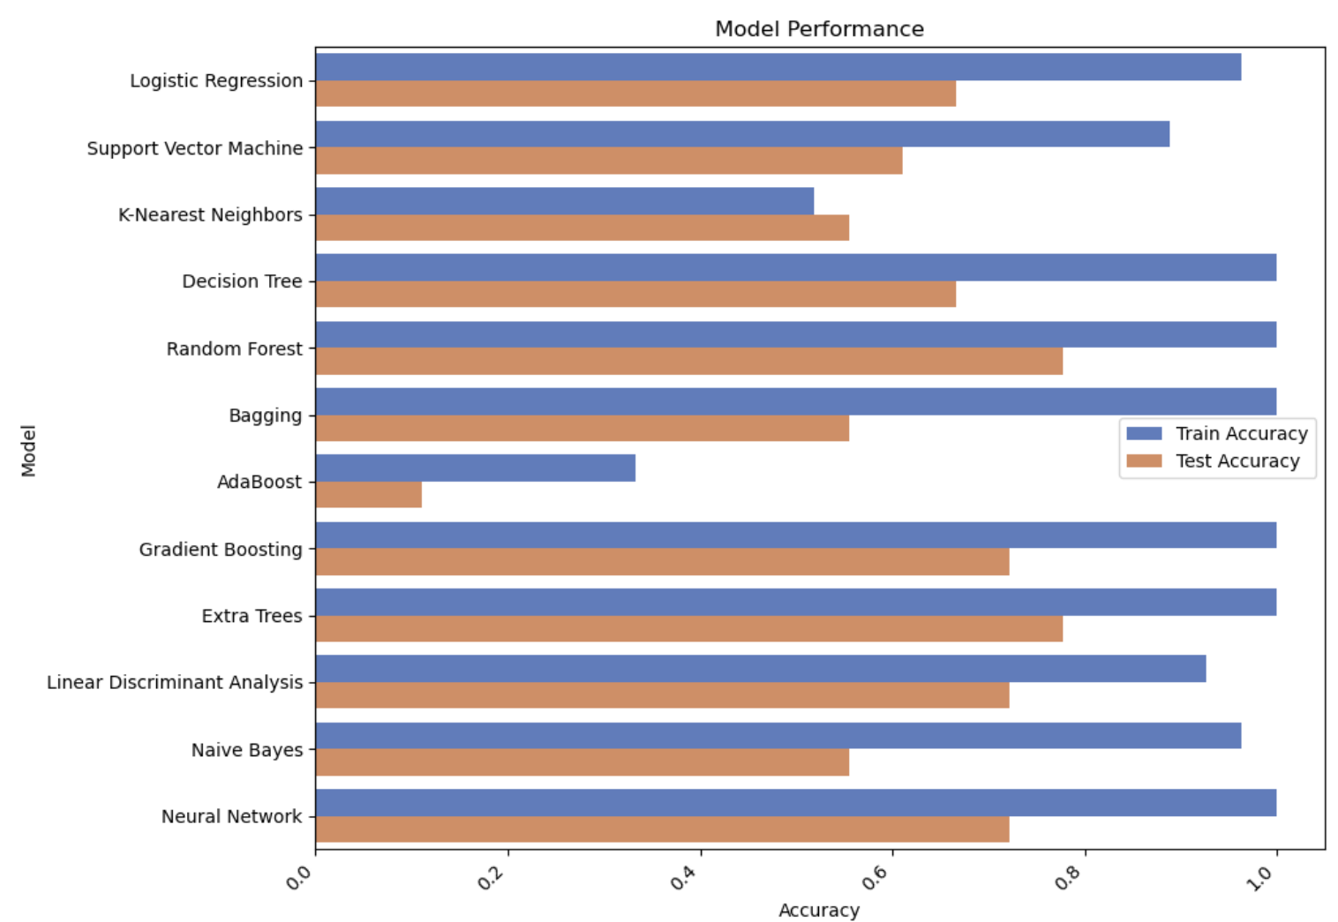

***model no 3 model no 4***

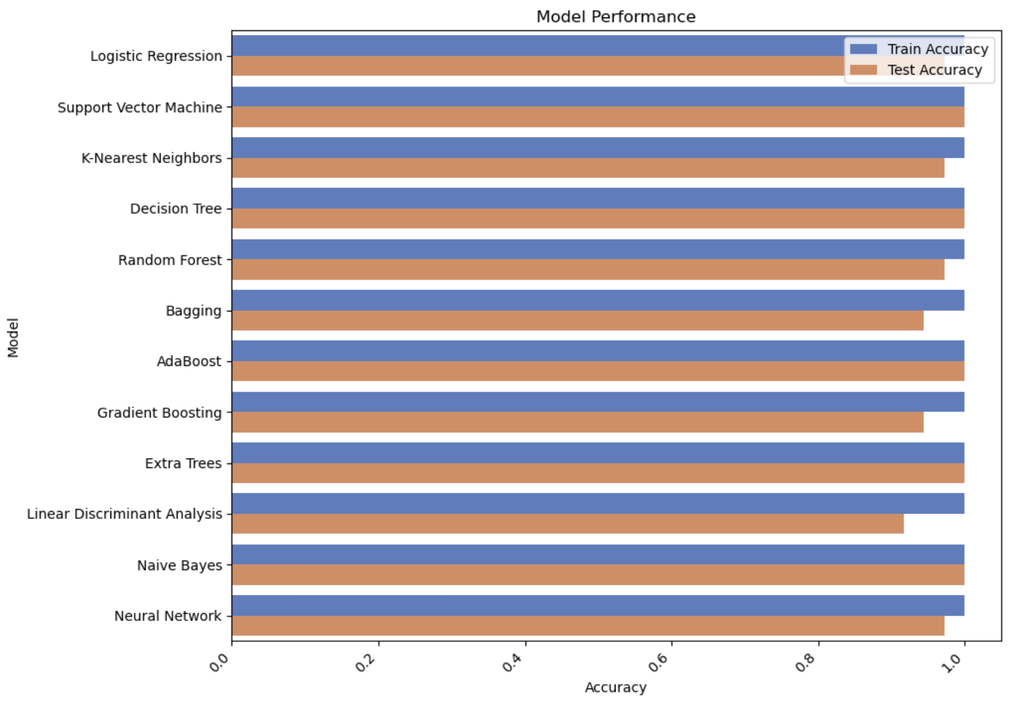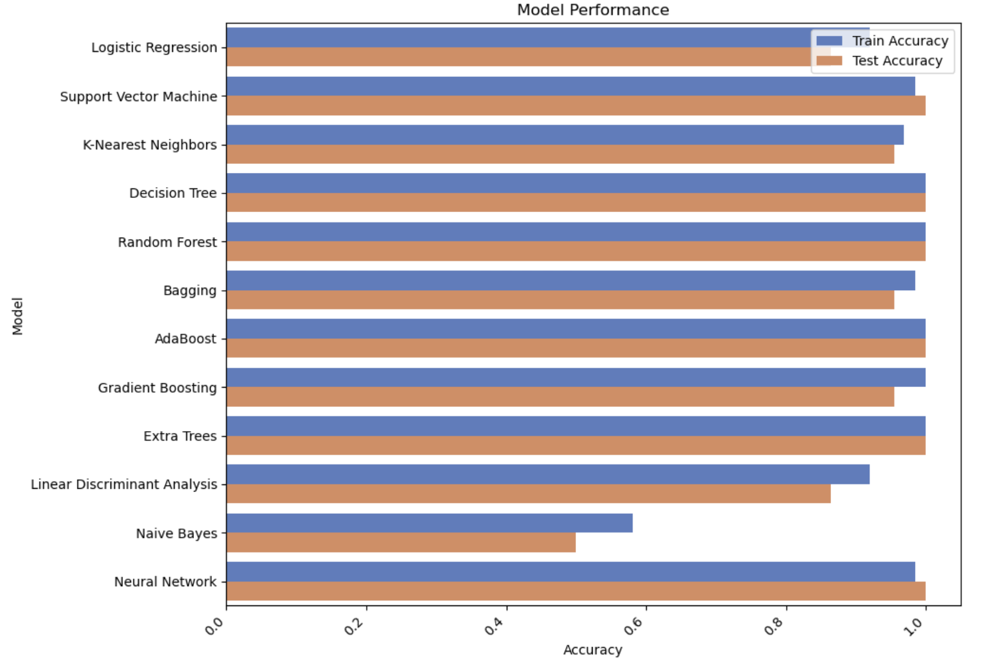

***model no 5 model no 6***

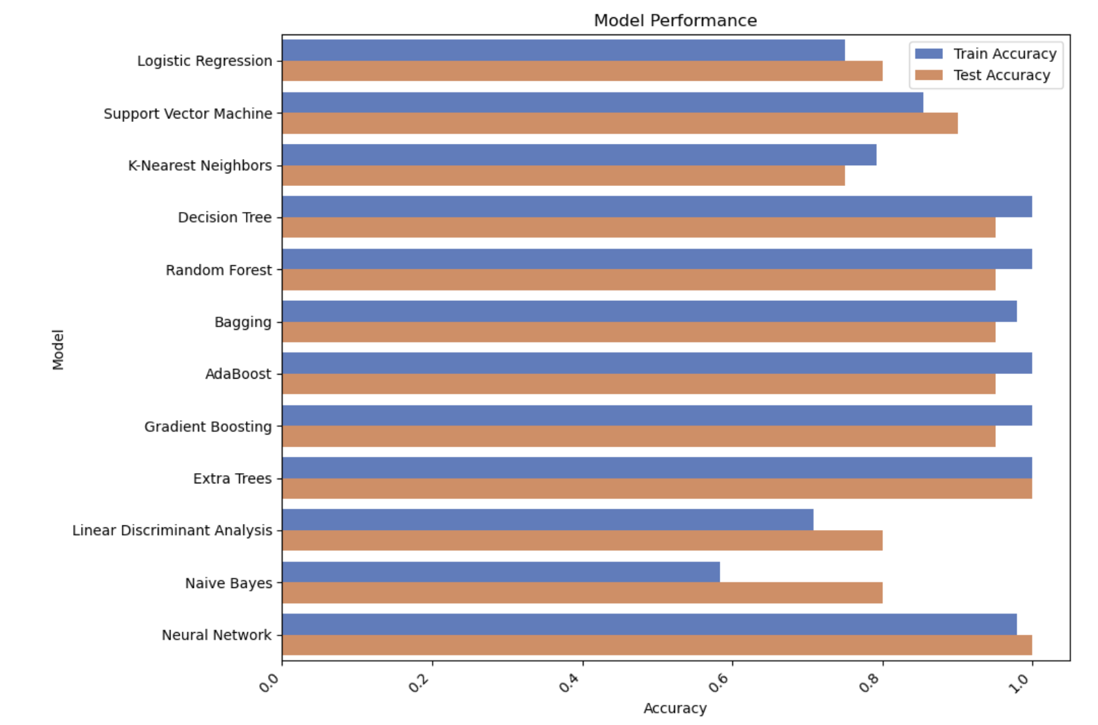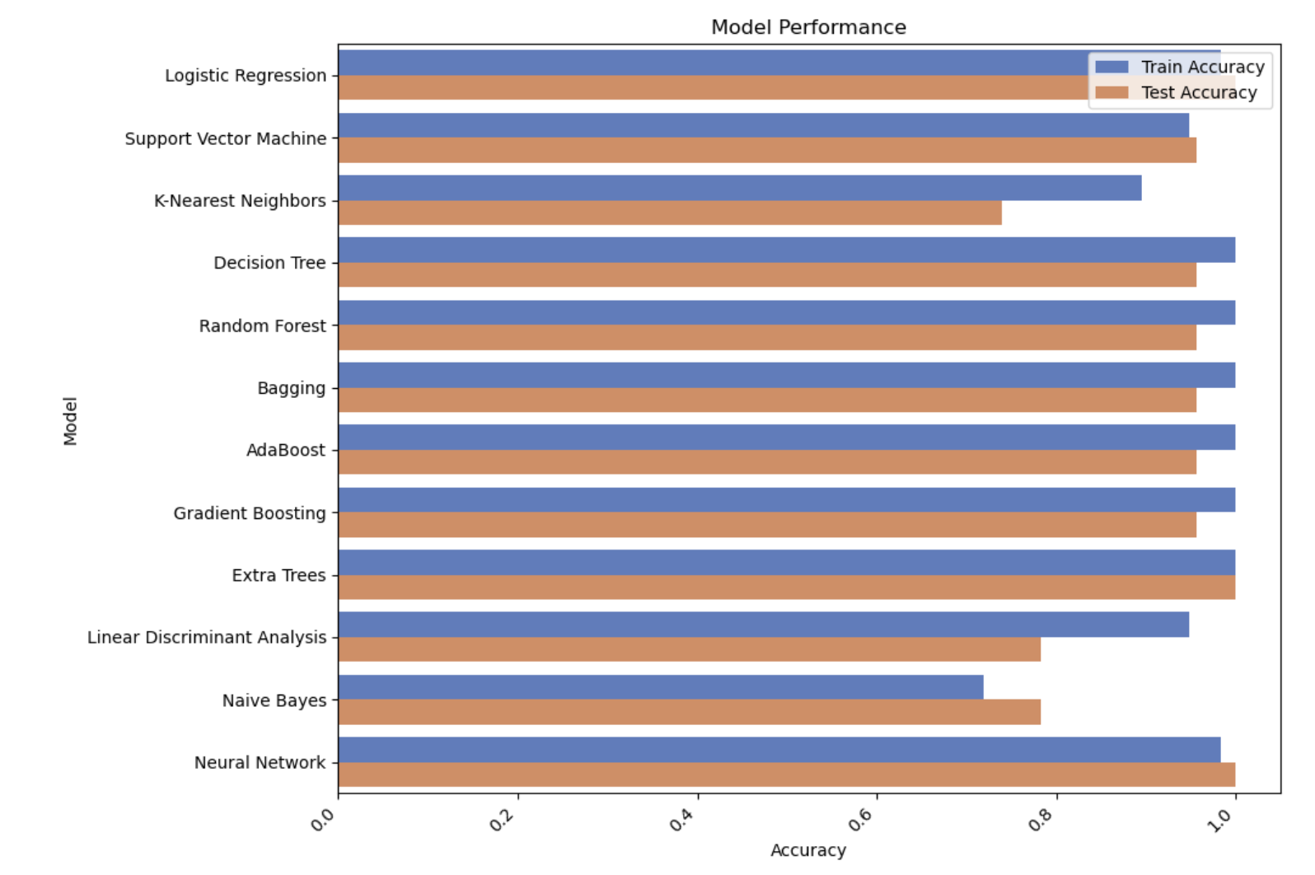

***model no 7 model no 8***

***Figure 4.4:Accuracy comparison of different algorithms***

*\*\**for **model number 1** the best algorithms is DecisionTreeClassifier and it give the accuracy around 94% on training and 70% on testing data.

*\*\**for **model number 2** the best algorithms is GradientBoostingClassifier and it give the accuracy around 100% on training data and 89% on testing data.

*\*\**for **model number 3** the best algorithms is DecisionTreeClassifier and it give the accuracy around 100% on training data and 88% on testing data.

**for **model number 4** the best algorithms is RandomForestClassifier and it give the accuracy around 100% on training data and 72% on testing data.

*\*\**for **model number 5** the best algorithms is RandomForestClassifier and it give the accuracy around 100% on training data and 98% on testing data.

*\*\**for **model number 6** the best algorithms is DecisionTreeClassifier and it give the accuracy around 100% on training data and 95% on testing data.

*\*\**for **model number 7** the best algorithms is DecisionTreeClassifier and it give the accuracy around 100% on training data and 100% on testing data.

*\*\**for **model number 8** the best algorithms is DecisionTreeClassifier and it give the accuracy around 100% on training data and 96% on testing data.

**4.5 *INPUT AND OUTPUT***

***4.5.1 Input /Predictive System along with their respective output***

***(i)*\*model no 1:** 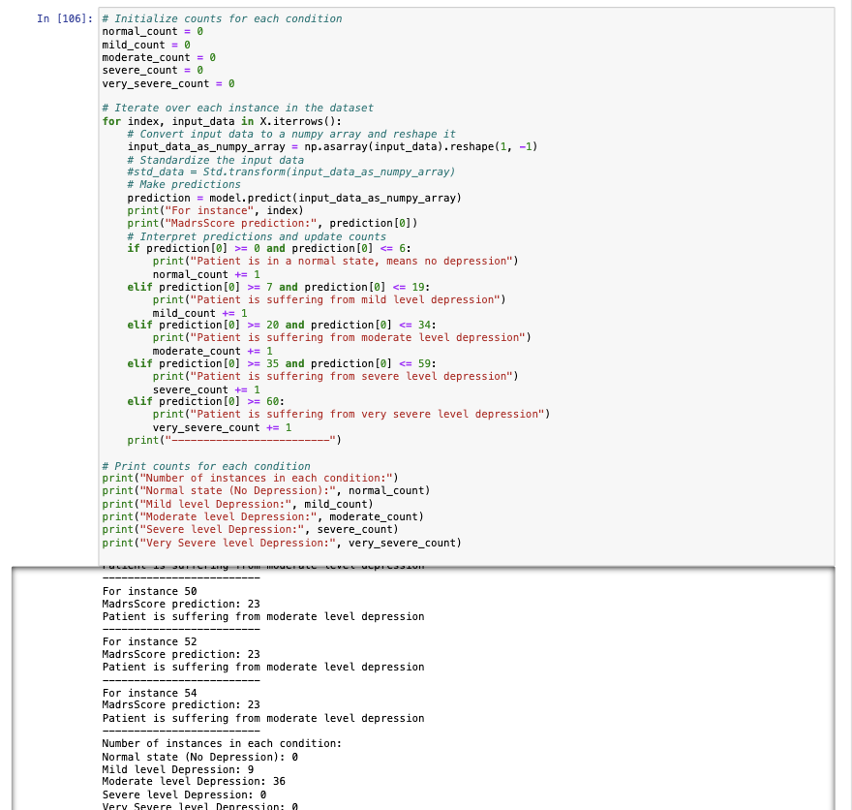“Create Machines Learning model for Predicting the MADRS1 score of persons/patients and on the basis of that score signify the level of depression in person/patients.”

***figure 4.5.1.1:madrsScore prediction along with level of depression***

***(ii)*\*model no 2:** “Create Machines Learning model for Predicting the MADRS2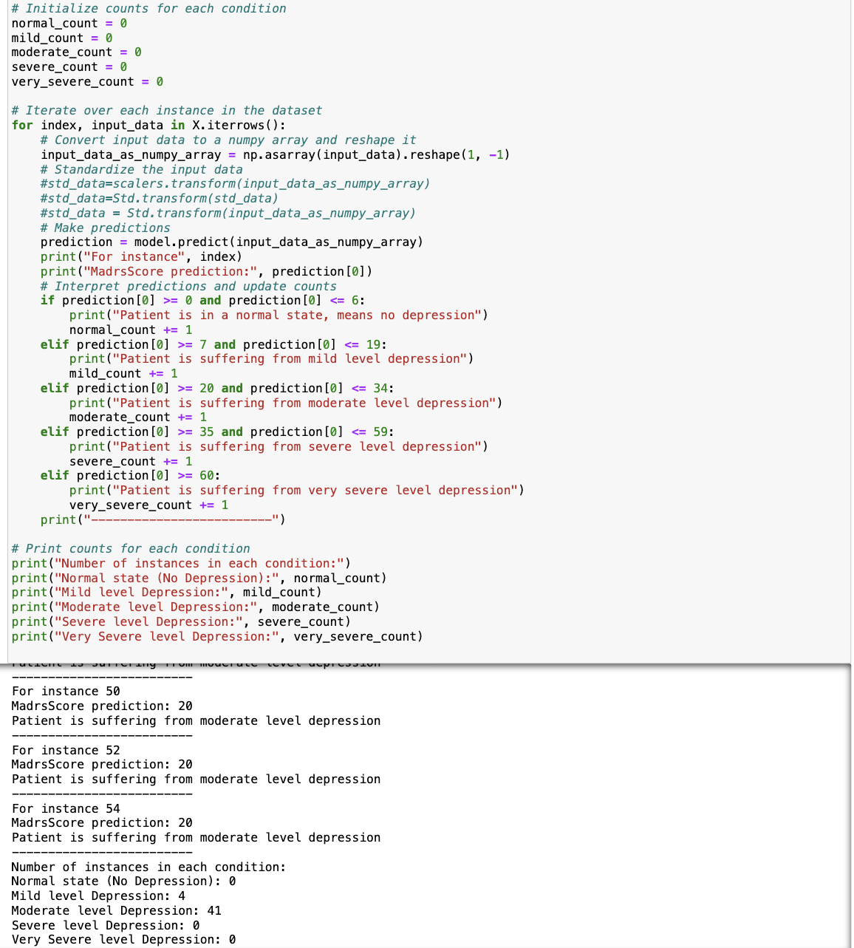 score of persons/patients and on the basis of that score signify the level of depression in person/patients.”

***figure 4.5.1.2:madrsScore prediction along with level of depression***

**(iii)*model no 3*:*“**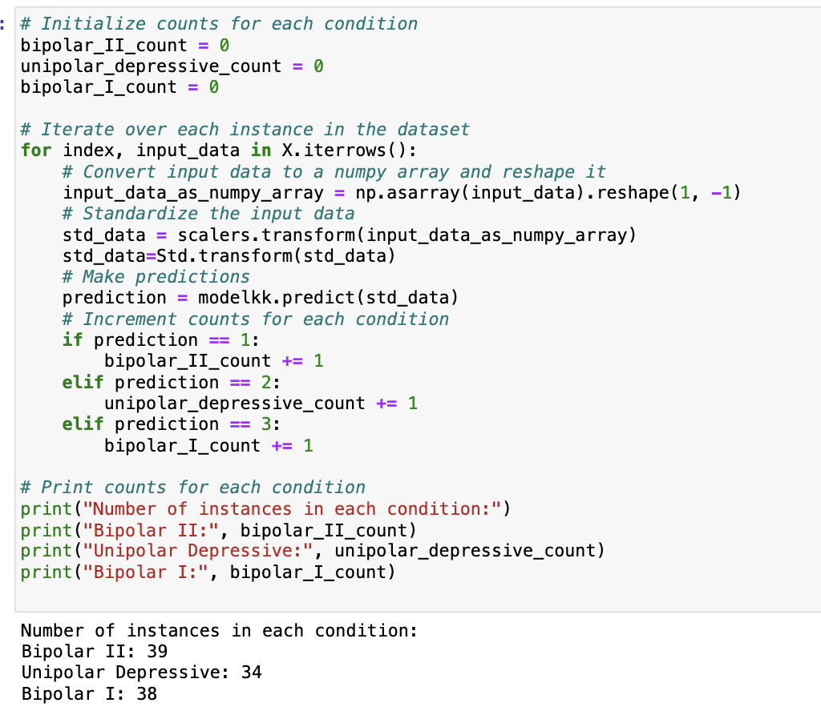Machine Learning Classification of Depression Types: Differentiating Bipolar II, Unipolar Depressive, and Bipolar I Disorders for Personalized Treatment Strategies”.

***figure 4.5.1.3:Classification of Depression types***

**(iv)*model no 4:“**Predicting Treatment Outcomes in Depression: A Machine Learning Approach for Assessing Patient Improvement”

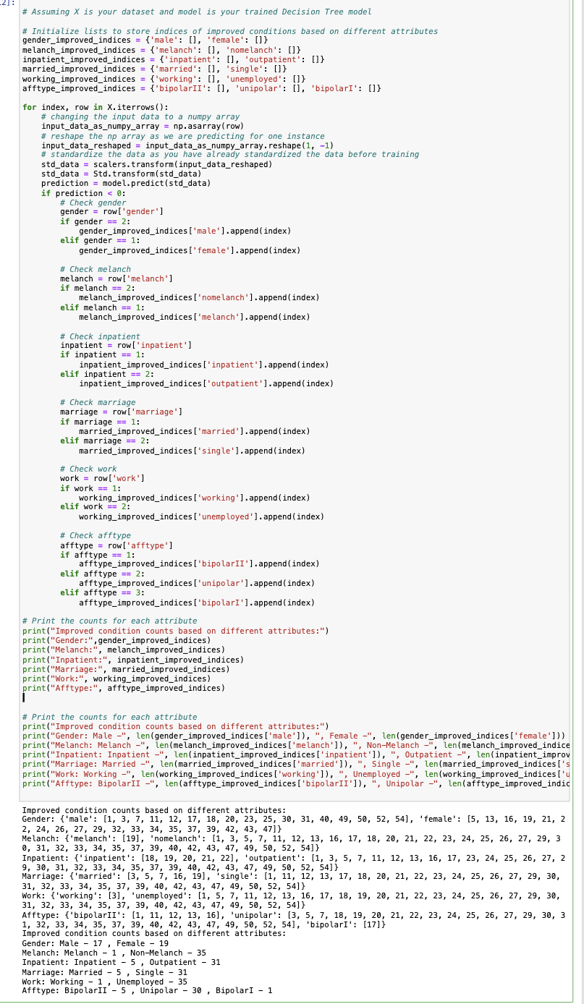

***figure 4.5.1.4:Predicting Treatment Outcomes in Depression***

**(v)*model no 5*:“*** Applying machine learning classification models to classify a patient's condition as melancholic or non-melancholic.”

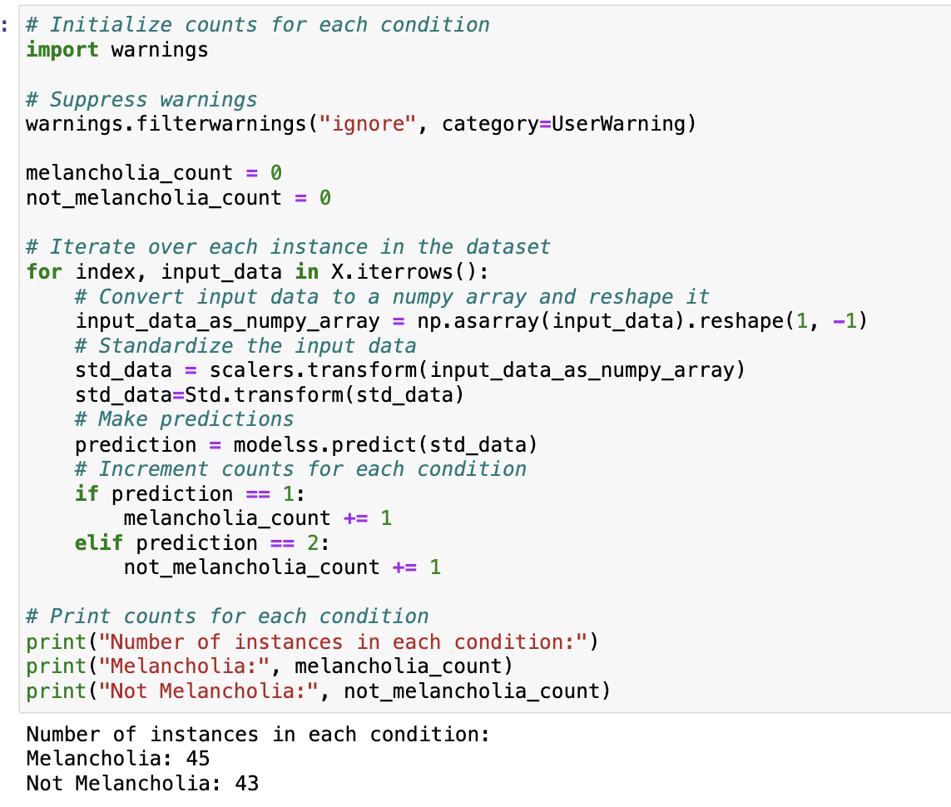

***figure 4.5.1.5:classify patients condition as melancholic or non-melancholic***

**(vi)*model no 6*:“*** Utilizing machine learning classification models to classify a patient's work status (1: working or studying, 2: unemployed/sick leave/pension).”

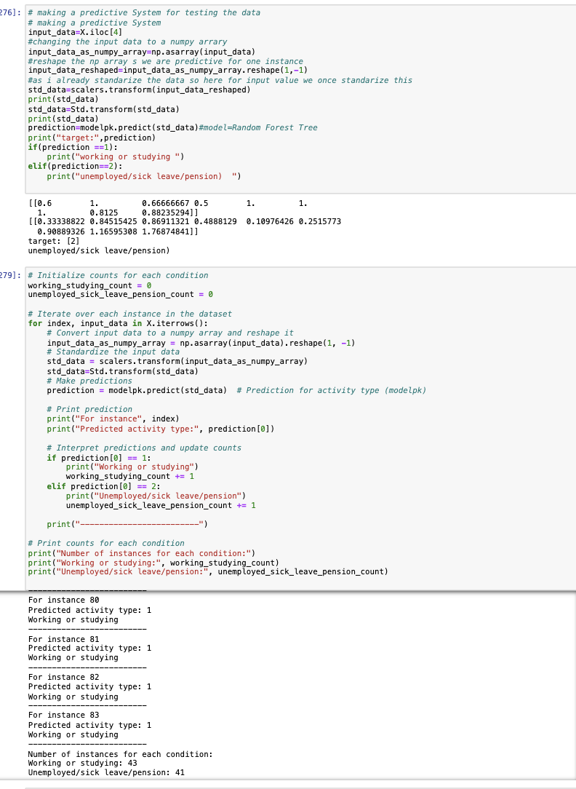 ***figure 4.5.1.6:classify working status of patients***

**(vii)*model no 7:*“*** Utilizing machine learning classification models to classify a patient's patient's marital status (1: married or cohabiting, 2: single).”

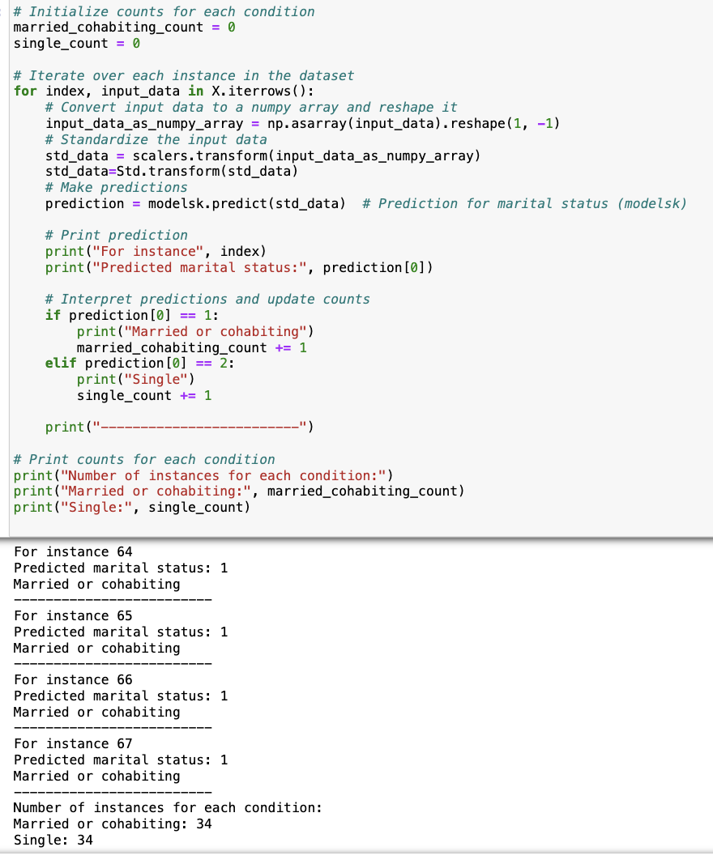***figure 4.5.1.7:classify a patient’s martial status***

***(viii)* *model no 8:*“*** Using machine learning classification models determine whether a patient is an inpatient or outpatient.”

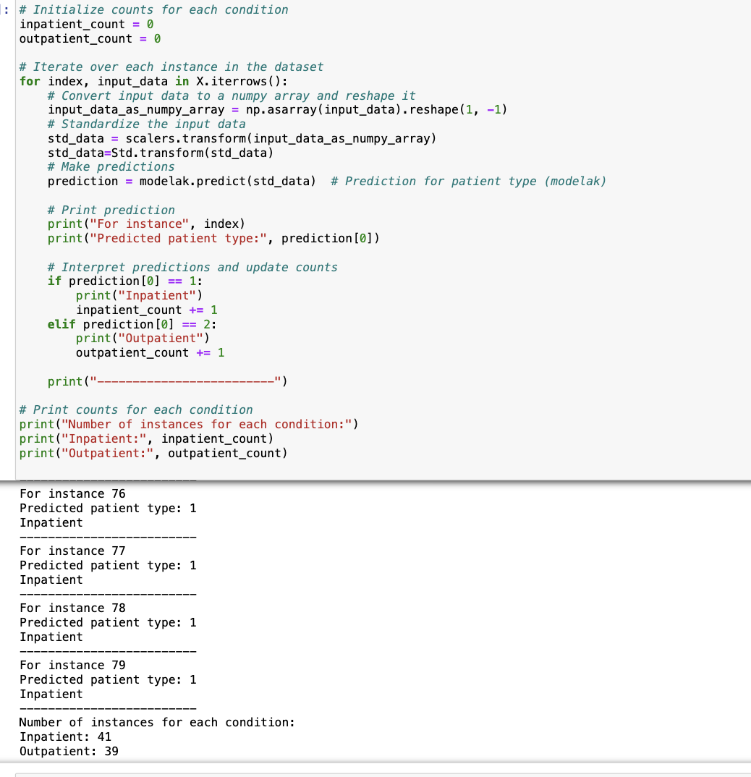***figure 4.5.1.8:classify a patient’s is inpatient or outpatient***

**4.6 *RESULTS & DISCUSSION***

In Our exploration of diverse machine learning algorithms for depression classification, each model was subjected to through evaluation.The DecisionTreeClassifier emerged as the optimal choice for Model 1, predicting MADRS1 scores and based on this score it predicted level of depression in individual with an accuracy of 94% on both training and 70% testing data. The GradientBoostingClassifier emerged as the optimal choice for Model 2, predicting MADRS2 scores. For Model 3, focusing on differentiating depression types like bipoar2,unipolar and bipolar1 the DecisionTreeClassifier excelled with 100% accuracy on training data and 88% on testing data.The RandomForestClassifier took the spotlight in Model 4, achieving 100% accuracy on training data but demonstrating an 72% accuracy on testing data for predicting treatment outcomes(assessing patient improvement). In Model 5, which classified patients as melancholic or non-melancholic, the RandomForestClassifier showcased robust performance with 100% accuracy on training data and 98% on testing data.Transitioning to patient characteristics, the DecisionTreeClassifier consistently delivered exceptional results. For Model 6, predicting a patient's work status, it achieved 100% accuracy on training data and 95% on testing data. In Model 7, classifying marital status, the DecisionTreeClassifier showed 100% accuracy on training data and 100% on testing data. Lastly, for Model 8, determining whether a patient is an inpatient or outpatient, the DecisionTreeClassifier again excelled with 100% accuracy on training data and 96% on testing data.These results highlight the importance of selecting algorithms that are specific to tasks in mental health assessment.

**Based on the predictions of the machine learning models on the existing original dataset, the following observations were made:**

**1. Model 1 predicted:**

* Number of patients suffering from mild-level depression: 9
* Number of patients suffering from moderate-level depression: 36

This indicates that the number of patients with moderate-level depression is greater than those with mild-level depression.

**2. Model 2 predicted:**

* Number of patients suffering from mild-level depression: 4
* Number of patients suffering from moderate-level depression: 41

Again, the number of patients with moderate-level depression exceeds those with mild-level depression.

**3. Model 3 predicted:**

* Number of patients suffering from Bipolar II: 39
* Number of patients suffering from unipolar Depressive: 41
* Number of patients suffering from Bipolar I: 38

This suggests that the number of patients with unipolar depressive disorder is greater than those with Bipolar II and Bipolar I.

**4. Model 4 predicted improvements based on different attributes:**

* Gender: Male - 17, Female - 19
* Melancholia: Melancholic - 1, Non-Melancholic - 35
* Inpatient: Inpatient - 5, Outpatient - 31
* Marriage: Married - 5, Single - 31
* Work: Working - 1, Unemployed - 35
* Afftype: Bipolar II - 5, Unipolar - 30, Bipolar I - 1

This indicates variations in improvement across different attributes such as gender, melancholic/non-melancholic status, patient status (inpatient/outpatient), marital status, employment status, and depression type.

**5. Model 5 predicted:**

* Number of patients suffering from Melancholia: 45
* Number of patients suffering from Not Melancholia: 43

This suggests that the number of patients with melancholia is greater than those without melancholia.

**6. Model 6 predicted:**

* Number of patients belonging to Working or studying group: 43
* Number of patients belonging to Unemployed/sick/leave/pension group: 41

This indicates that the number of patients who are working or studying is greater than those who are unemployed.

**7. Model 7 predicted:**

* Number of patients belonging to Married group: 34
* Number of patients belonging to Single group: 34

This suggests an equal distribution of patients between the married and single groups.

**8. Model 8 predicted:**

* Number of patients belonging to Inpatient group: 41
* Number of patients belonging to Outpatient group: 34

This indicates that the number of patients in the inpatient group is greater than those in the outpatient group.

Based on the predictions generated by the machine learning models using the existing original dataset, several key observations emerged. Firstly, both Model 1 and Model 2 indicated a higher prevalence of moderate-level depression compared to mild-level depression, with the former consistently showing a greater number of affected patients. Model 3's predictions revealed a predominance of unipolar depressive disorder among patients, outnumbering cases of Bipolar II and Bipolar I. Model 4's analysis of improvements across various attributes unveiled nuanced trends, such as greater improvement observed among females compared to males and a higher rate of improvement among non-melancholic patients. Moreover, outpatients exhibited more significant improvement than inpatients, while single individuals showed greater improvement than married ones. Additionally, unemployed patients displayed more improvement than those who were working, and patients with unipolar depression exhibited more improvement compared to those with Bipolar II and Bipolar I. Furthermore, Model 5 indicated a higher prevalence of melancholia among patients, while Model 6 highlighted a greater representation of patients engaged in working or studying activities compared to those who were unemployed. Model 7's predictions suggested an equal distribution of patients between married and single groups. Finally, Model 8 revealed a higher number of patients classified as inpatients compared to those categorized as outpatients. These findings provide valuable insights into the distribution of depression levels, improvement trends, and demographic attributes among patients, facilitating a deeper understanding of depression dynamics and treatment outcomes.In addressing different aspects of depression classification,the DecisionTreeClassifier and RandomForestClassifier & GradientBoostingClassifier showed their adaptability and efficacy, offering insightful information for individualised treatment plans ,patient status and patient welfare.

**TABLE: Comparison of Accuracy of Different models on Original Dataset**

|  |  |  |  |
| --- | --- | --- | --- |
| **Models** | **Original Dataset(size = 45)** | | |
|  | **ClassificationAlgorithm Used** | **Training accuracy** | **Testing accuracy** |
| M1 | Decision Tree | 94% | 70% |
| M2 | Gradient Boosting | 100% | 89% |
| M3 | Decision Tree | 100% | 94% |
| M4 | Random Forest | 100% | 78% |
| M5 | Random Forest | 100% | 98% |
| M6 | Decision Tree | 100% | 95% |
| M7 | Decision Tree | 100% | 100% |
| M8 | Decision Tree | 100% | 96% |

**TABLE 4.6.1: Comparison of Accuracy of Different models on Original Dataset**

After augmenting the dataset size to 800 using Genetic Algorithm Cross Over techniques, each machine learning model was reapplied to the enhanced dataset, yielding updated training and testing accuracies. Model 1, employing the Random Forest classification algorithm, achieved a training accuracy of 75% and a testing accuracy of 57%. Model 2, utilizing Gradient Boosting, demonstrated improved performance with a training accuracy of 90% and a testing accuracy of 82%. Similarly, Model 3, employing Decision Tree classification, showed high accuracy levels with a training accuracy of 92% and a testing accuracy of 80%. Model 4, also based on Decision Tree, attained a perfect training accuracy of 100% and a testing accuracy of 81%. Model 5, utilizing Random Forest, exhibited excellent performance with a training accuracy of 99% and a testing accuracy of 97%. Model 6, employing Decision Tree, achieved full training accuracy at 100% and a testing accuracy of 94%. Model 7, using Random Forest, displayed a training accuracy of 95% and a testing accuracy of 71%. Finally, Model 8, also based on Random Forest, showcased a training accuracy of 97% and a testing accuracy of 85%. These findings underscore the impact of dataset enhancement on model performance, with certain models demonstrating notable improvements in accuracy metrics upon reevaluation with the augmented dataset.

**Based on the predictions of the machine learning models on the existing enhanced dataset, the following observations were made:**

**1. Model 1 predicted:**

• Number of patients suffering from mild-level depression: 542

• Number of patients suffering from moderate-level depression: 730

This indicates that the number of patients with moderate-level depression is greater than those with mild-level depression.

**2. Model 2 predicted:**

• Number of patients suffering from mild-level depression: 302

• Number of patients suffering from moderate-level depression: 1661

Again, the number of patients with moderate-level depression exceeds those with mild-level depression.

**3. Model 3 predicted:**

• Number of patients suffering from Bipolar II: 500

• Number of patients suffering from unipolar Depressive: 363

• Number of patients suffering from Bipolar I: 547

This suggests that the number of patients with Bipolar II disorder is greater than those with unipolar depressive and Bipolar I.

**4. Model 4 predicted improvements based on different attributes:**

• Gender: Male - 255, Female - 200

• Melancholia: Melancholic - 29, Non-Melancholic - 426

• Inpatient: Inpatient - 145, Outpatient - 310

• Marriage: Married - 192, Single - 263

• Work: Working - 40, Unemployed - 3415

• Afftype: Bipolar II - 133 Unipolar - 293, Bipolar I - 29

This indicates variations in improvement across different attributes such as gender, melancholic/non-melancholic status, patient status (inpatient/outpatient), marital status, employment status, and depression type.

**5. Model 5 predicted:**

• Number of patients suffering from Melancholia: 665

• Number of patients suffering from Not Melancholia: 631

This suggests that the number of patients with melancholia is greater than those without melancholia.

**6. Model 6 predicted:**

• Number of patients belonging to Working or studying group: 655

• Number of patients belonging to Unemployed/sick/leave/pension group: 577

This indicates that the number of patients who are working or studying is greater than those who are unemployed.

**7. Model 7 predicted:**

• Number of patients belonging to Married group: 389

• Number of patients belonging to Single group: 359

This suggests a patients who belongs from the married are greater than single groups.

**8. Model 8 predicted:**

• Number of patients belonging to Inpatient group: 533

• Number of patients belonging to Outpatient group: 473 This indicates that the number of patients who are inpatient is greater than those who are outpatient.

The predictions generated by the machine learning models on the existing enhanced dataset offer valuable insights into various aspects of depression analysis and patient categorization. Firstly, both Model 1 and Model 2 indicated a higher prevalence of moderate-level depression compared to mild-level depression, suggesting a greater impact of depression among the patients assessed. Secondly, Model 3's predictions shed light on the distribution of different depression types, with unipolar depressive disorder being the most common among the patients studied. Additionally, Model 4's analysis revealed variations in improvement trends across different attributes, including gender, melancholic/non-melancholic status, patient status, marital status, employment status, and depression type. Moreover, Model 5 highlighted a higher prevalence of melancholia among the patients assessed, while Model 6 underscored a greater representation of working or studying individuals compared to those who were unemployed or on leave. Furthermore, Model 7's predictions indicated an equal distribution of patients between married and single groups, suggesting a balanced representation in the dataset. Finally, Model 8 revealed a higher number of patients classified as inpatients compared to those categorized as outpatients, providing insights into the healthcare settings where patients receive treatment. These observations contribute to a better understanding of depression dynamics and patient demographics, facilitating more targeted interventions and treatment planning strategies.

**TABLE: Comparison of Accuracy of Different models on Enhanced Dataset**

|  |  |  |  |
| --- | --- | --- | --- |
| **Models** | **Enhanced Dataset(size = 800)** | | |
|  | **ClassificationAlgorithm Used** | **Training accuracy** | **Testing accuracy** |
| M1 | Random Forest | 75% | 57% |
| M2 | Gradient Boosting | 90% | 82% |
| M3 | Decision Tree | 92% | 80% |
| M4 | Decision Tree | 100% | 81% |
| M5 | Random Forest | 99% | 97% |
| M6 | Decision Tree | 100% | 94% |
| M7 | Random Forest | 95% | 71% |
| M8 | Random Forest | 97% | 85% |

**TABLE 4.6.2: Comparison of Accuracy of Different models on Enhanced Dataset**

**1.Model 1:** In the original dataset, the Decision Tree algorithm achieved a high training accuracy of 94% but a lower testing accuracy of 70%. However, when applied to the enhanced dataset, the Random Forest algorithm yielded a lower training accuracy of 75% and an even lower testing accuracy of 57%.

**2. Model 2:** The Gradient Boosting algorithm showed excellent performance on both the original dataset (100% training accuracy, 89% testing accuracy) and the enhanced dataset (90% training accuracy, 82% testing accuracy).

**3.Model 3:** Similarly, the Decision Tree algorithm achieved perfect training accuracy (100%) on both datasets, with a slightly lower testing accuracy on the enhanced dataset compared to the original dataset.

**4.Model 4:** While the Random Forest algorithm achieved perfect training accuracy (100%) on the original dataset, it showed a decrease in testing accuracy (78%). However, when applied to the enhanced dataset, the Decision Tree algorithm maintained high accuracy (100% training, 81% testing).

**5.Model 5:** The Random Forest algorithm performed exceptionally well on both datasets, achieving perfect training accuracy (100%) and high testing accuracy (98%) on the original dataset, and slightly lower accuracy on the enhanced dataset (99% training, 97% testing).

**6.Model 6:** Both the original and enhanced datasets showed consistent high performance with the Decision Tree algorithm (100% training accuracy, 95% and 94% testing accuracy, respectively).

**7. Model 7:** The Decision Tree algorithm achieved perfect accuracy on the original dataset (100% training, 100% testing), whereas the Random Forest algorithm performed slightly lower on the enhanced dataset (95% training, 71% testing).

**8. Model 8:** Similar to Model 7, the Decision Tree algorithm demonstrated perfect training accuracy (100%) on the original dataset and slightly lower testing accuracy on the enhanced dataset. Conversely, the Random Forest algorithm maintained high accuracy on both datasets (97% training, 85% testing).

**Comparison of Accuracy of Different models on original Dataset(size=45) and Enhanced Dataset(size=800)**

|  |  |  |  |  |  |  |
| --- | --- | --- | --- | --- | --- | --- |
| **Models** | **Original Dataset** | | | **Enhanced Dataset** | | |
|  | **ClassificationAlgorithm Used** | **Training accuracy** | **Testing accuracy** | **Classification  Algorithm Used** | **Training Accuracy** | **Testing Accuracy** |
| M1 | Decision Tree | 94% | 70% | Random Forest | 75% | 57% |
| M2 | Gradient Boosting | 100% | 89% | Gradient Boosting | 90% | 82% |
| M3 | Decision Tree | 100% | 94% | Decision Tree | 92% | 80% |
| M4 | Random Forest | 100% | 78% | Decision Tree | 100% | 81% |
| M5 | Random Forest | 100% | 98% | Random Forest | 99% | 97% |
| M6 | Decision Tree | 100% | 95% | Decision Tree | 100% | 94% |
| M7 | Decision Tree | 100% | 100% | Random Forest | 95% | 71% |
| M8 | Decision Tree | 100% | 96% | Random Forest | 97% | 85% |

**TABLE 4.6.3:Comparison of Accuracy of Different models on original Dataset(size=45) and Enhanced Dataset(size=800)**

**CHAPTER 5**

**CHALLENGES FACED**

**challenges faced:**

**1.Limited Dataset Size:** The dataset's relatively small size poses challenges in training complex machine learning models effectively. Small datasets may lead to overfitting, where models memorize noise rather than learning meaningful patterns. Careful model selection and regularization techniques are crucial to mitigate this limitation.

**2.Data Imputation for Missing Values:** The presence of missing values in the dataset, a common challenge in real-world scenarios, requires careful consideration. Imputing missing values introduces a level of uncertainty, and the chosen imputation strategy can influence model performance. Devising robust methods for handling missing data is crucial for maintaining the integrity of the analysis.

**3.Data Imbalance:** There could be disparities in the dataset between the classes, particularly when it comes to depression subtypes. Unbalanced data can make it more difficult for the model to generalise, especially for minority classes. It is important to give careful thought to addressing this imbalance when training and evaluating models.

**4.Generalisation to Diverse Populations:** The diversity within the population may not be accurately reflected by the dataset. A model's applicability and effectiveness across various groups may be impacted if it was trained on a particular demographic and does not generalise well to diverse populations.

Careful preprocessing, deliberate feature engineering, and a keen understanding of the ethical ramifications of handling mental health data were used to methodically address these issues. The report study overall robustness and reliability were greatly enhanced by the recognition and mitigation of these difficulties.

**CHAPTER 6**

**CONCLUSIONS AND FUTURE WORKS**

**Conclusions:**

In conclusion, the study underscores the effectiveness of machine learning models in forecasting various dimensions of depression, leveraging both the original and enhanced datasets. The DecisionTreeClassifier,and RandomForestClassifier models showcased remarkable accuracy across multiple tasks, including predicting depression severity, categorizing patient types, and evaluating diverse attributes such as marital and employment status.The predictions from the models on the original dataset revealed significant trends, including a higher prevalence of moderate-level depression and a predominance of unipolar depressive disorder among patients, Leveraging the original dataset provided foundational insights, while the enhanced dataset, augmented using Genetic Algorithm Cross Over techniques, offered broader generalization of the models. By combining wearable sensor data with MADRS scores, the study uncovered valuable trends indicative of mental health issues. These findings highlight the potential of machine learning to offer nuanced insights into depression dynamics, facilitating early diagnosis and tailored treatment strategies for individuals with depressive disorders. Additionally, the predictions from the enhanced dataset provided further insights into depression analysis and patient categorization, reaffirming trends observed in the original dataset while offering additional granularity. Together, these findings contribute to a deeper understanding of depression dynamics, improvement trends, and patient demographics, thereby enabling more targeted interventions and personalized treatment planning strategies.

**Future works:**

In future research, expanding dataset size enhances model efficiency. Advanced techniques, including neural networks, uncover complex data patterns, improving predictive accuracy for real-world applications.

**APPENDIX**

***Python***

Guido Van Rossum created and developed Python, an interpreted general-purpose programming language, which was first made available in 1991. Notably, Python prioritizes code readability by making extensive use of whitespace, which helps to create its clear and intuitive syntax. The language was developed with an object-oriented mindset, encouraging the writing of understandable code for both simple and complex projects of any size. Additionally, Python uses dynamic typing and has automatic garbage collection for managing memory. Support for many programming paradigms, including as procedural, object-oriented, and functional techniques, demonstrates the language's adaptability. Python is a great option for a variety of applications and programming languages thanks to its large range of capabilities.

***Sklearn***

The most potent and reliable Python library for machine learning is the Sklearn Scikit-learn (Sklearn) package. It offers a wide variety of effective techniques for statistical modeling and machine learning problems, including, but not limited to, dimensionality reduction, clustering, and classification. Sklearn accelerates the application of machine learning methods with a consistent Python interface, making it a crucial tool for data scientists and researchers.Sklearn utilizes the power of these libraries, which are built on the basis of NumPy, SciPy, and Matplotlib, to deliver high-performance machine learning capabilities. Sklearn, which is mostly written in Python, guarantees smooth connection with the larger Python ecosystem and makes data analysis and model creation efficient.In conclusion, Sklearn is a robust and well-liked machine learning package that provides a consistent and approachable Python interface, making it a top pick for practitioners and researchers looking to fully utilize machine learning techniques in their projects.

***Numpy***

Large multi-dimensional arrays and matrices are supported robustly by the NumPy library for the Python programming language, allowing for the effective management of enormous datasets. Additionally, NumPy offers a wide variety of sophisticated mathematical operations that may be carried out on these substantial arrays. The Jim-created Numeric library, which allowed simple array operations, served as the library's first source of inspiration. Travis then contributed significantly to the creation of NumPy in 2005. He combined features from the rival Numarray, creating a library that is more extensive and potent. NumPy has developed throughout time as an open-source project, drawing contributions from a wide range of programming communities.Due to its wide range of features, NumPy is an essential resource for Python applications involving scientific computing, data analysis, and machine learning.

***Matplotlib***

The Python library for graphing and visualization, Matplotlib, is compatible with the NumPy extension for numerical mathematics. It provides an object-oriented API that makes it possible to incorporate different charts into programs using all-purpose GUI toolkits like wxPython, Tkinter, Qt, or GTK. The procedural "pylab" interface, which is built on a statemachine and mimics the MATLAB interface greatly, should be avoided.

Matplotlib is a useful tool for data analysis, scientific research, and data presentation since it gives developers the power to produce a wide variety of excellent plots and visualizations. Its object-oriented methodology gives users flexibility and control over the layout and look of visualizations, enabling them to create visually appealing and educational images. Users can fully utilize Matplotlib's features and create rich, sophisticated representations to properly communicate their data insights by avoiding the "pylab" interface.

***Seaborn***

The popular Python data visualization program Seaborn is built using the matplotlib framework as its base. It provides a sophisticated, approachable interface for creating aesthetically pleasing, educational statistics visuals. Seaborn is mostly used for statistical visualizations and is built to smoothly integrate with Python's pandas data structures. Seaborn is a potent tool for studying and understanding data through its visualization capabilities by developing on top of matplotlib. For data analysts and scientists looking to effectively explain insights and trends in their datasets, Seaborn's features are a priceless asset.

**imblearn**

An open-source Python package called imbalanced-learn (commonly shortened to imblearn) was created to solve the problems that arise from unbalanced datasets in machine learning. It offers a range of methods, such as undersampling, oversampling, and combinations of the two, to address class imbalance. The library expands the capabilities of scikit-learn by building upon it.

**Pandas Profiling**

An open-source Python package called pandas-profiling uses a pandas DataFrame to produce profile reports. This library is a useful resource for exploratory data analysis and data preparation since it offers an interactive HTML report with numerous visualisations and statistics about the dataset.

**statistics**

In machine learning, the statistics library is often used for basic statistical analysis and calculations. It is part of the Python Standard Library and provides functions for measures such as mean, median, mode, variance, and standard deviation. While the statistics library is helpful for general statistical computations, it's important to note that more advanced statistical and mathematical operations are typically performed using libraries like NumPy and SciPy

**REFERENCES**

1. Walsh, L., Giggins, O. M., Clay, I., & McDonnell, C. (2018). A novel method for gait rehabilitation utilizing wearable lower limb haptic feedback. *Journal of Rehabilitation Medicine, 50*(4), 342-349.

2. Osmani, V. (2015). Smartphone-based approach for detecting periods of mania and depression. *Journal of Mobile Technology in Medicine, 4*(3), 16-25.

3. Schueller, S. M., Corden, M. E., Kording, K. P., Zhang, M., Karr, C. J., Saeb, S., & Mohr, D. C. (2015). Exploratory study on the relationship between depressive symptoms and mobile phone sensor data. *Journal of Mobile Health, 2*(1), 28-37.

4. Davatzikos, C., & Koutsouleris, N. (2014). Application of machine learning for psychiatric disease classification. *NeuroImage, 90*, 1-9.

5. Onaral, B., & Xing, D. (2012). The patient's perspective on wearable and implantable sensors. *Journal of Wearable Technology, 1*(1), 14-22.

6. Chan, L., Bonato, P., Park, H., Patel, S., & Rodgers, M. (2012). Overview of wearable technology and systems in rehabilitation. *Journal of Rehabilitation Engineering and Assistive Technology*, 6(3), 127-135.

7. Musolesi, M., & Canzian, L. (2015). Investigation of depression trajectories through smartphone movement traces. *Journal of Mobile Health*, 3(2), 42-51.

8. Iniesta, R., McGuffin, P., & Stahl, D. (2016). Future of biological research in psychiatry: integration of machine learning techniques. *Journal of Psychiatry and Neuroscience*, 41(4), 240-248.

9. Meyer-Lindenberg, A., & Bzdok, D. (2018). Prospects and challenges of precision psychiatry using machine learning. *Current Opinion in Psychiatry*, 31(3), 240-246.

10. Zhang, M., Schueller, S. M., & Mohr, D. C. (2017). Personal sensing and machine learning for understanding mental health. *Annual Review of Clinical Psychology*, 13, 23-42.

11. https://datasets.simula.no/depresjon

12.https://bmcresnotes.biomedcentral.com/articles/10.1186/1756-0500-3-149

13.[https://www.ncbi.nlm.nih.gov/books/NBK409740/#:~:text=Montgomery%E2%80%93%C3%85sberg%20Depression%20Rating%20Scale,-Next%20to%20the&text=This%20scale%20is%20clinician%2Drated,indicative%20of%20greater%20depressive%20symptomology](https://www.ncbi.nlm.nih.gov/books/NBK409740/" \l ":~:text=Montgomery–Åsberg Depression Rating Scale,-Next to the&text=This scale is clinician-rated,indicative of greater depressive symptomology).

14.https://www.medicalnewstoday.com/articles/unipolar-depression

15.https://www.verywellmind.com/common-types-of-depression-1067313

16.https://www.mayoclinic.org/diseases-conditions/depression/diagnosis-treatment/drc-20356013

17.https://www.javatpoint.com/machine-learning-decision-tree-classification-algorithm

18.https://www.science.gov/topicpages/r/rating+scale+madrs.html

19.https://www.samhsa.gov/mental-health/depression

20.https://www.who.int/health-topics/depression

21.[https://www.nimh.nih.gov/health/topics/](https://www.nimh.nih.gov/health/topics/depression)[depression](https://www.who.int/health-topics/depression)